## Lab 2-01: Create an Azure Resource

### Service Introduction

WorkTrips.com is a Polish company offering a modern platform that optimizes costs, automates processes and provides care during business trips. To handle multiple requests at high speed and to simplify the flow of arranging business travel, it connects various Azure services via Azure Virtual Networking.

### Problem

The process is not automated and the users would have to check offers, find the one matching their needs, and send an email to the supervisor to get approval.

### Solution

Now, the system can automatically approve the trip if all criteria and limits are met. The superior does not have to be involved. Azure Virtual Machines can be scaled up and down quickly, enabling WorkTrips.com to handle peaks in demand when there are large numbers of requests. The geographical distribution of Azure data centers also gives WorkTrips.com a competitive advantage.

#### Task 1: Create a Virtual Machine

1. Sign in to the Azure portal.

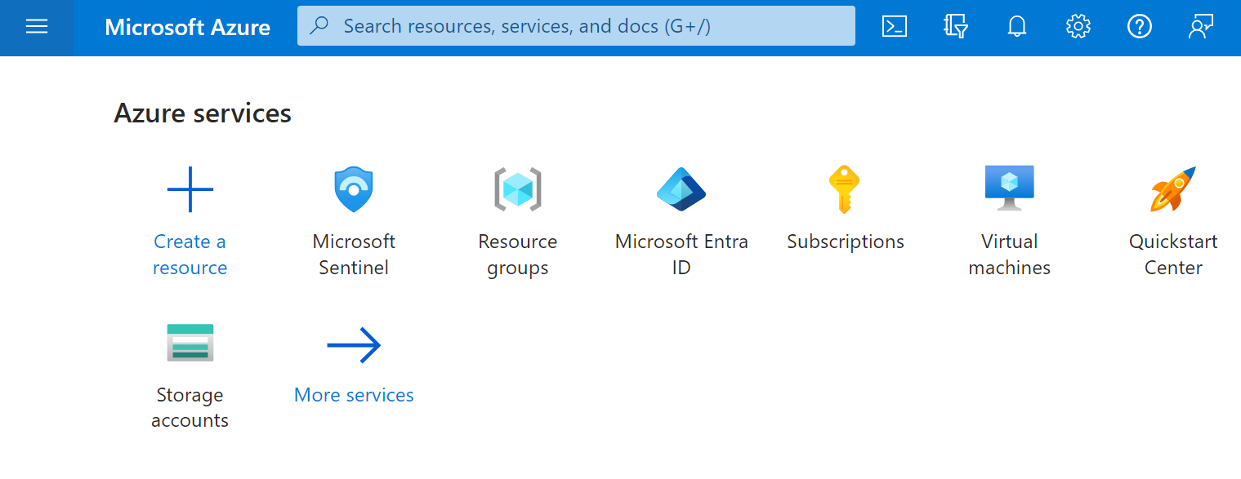

2. Select Create a resource > Virtual Machine > Create.

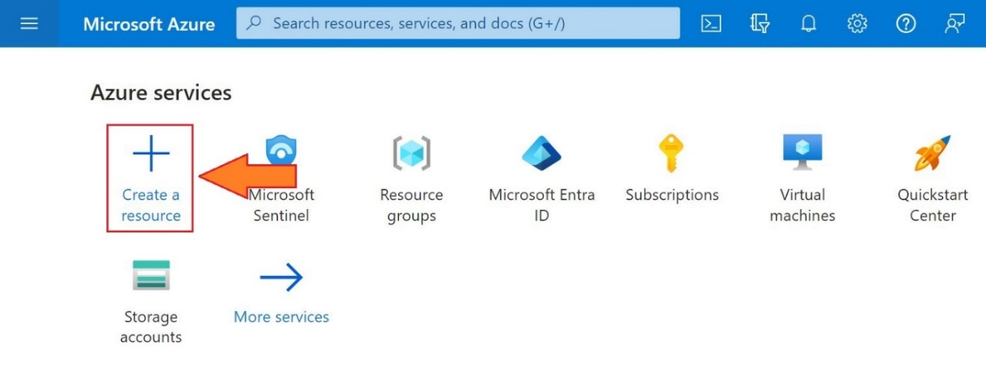

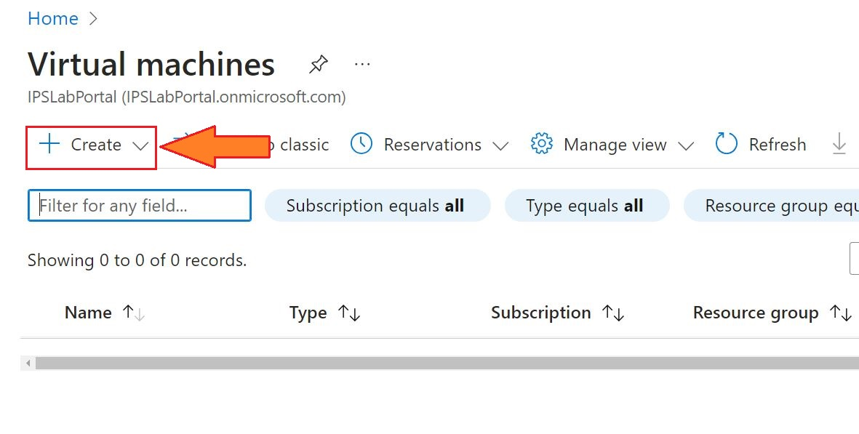

3. Create a virtual machine pane that opens to the basics tab.

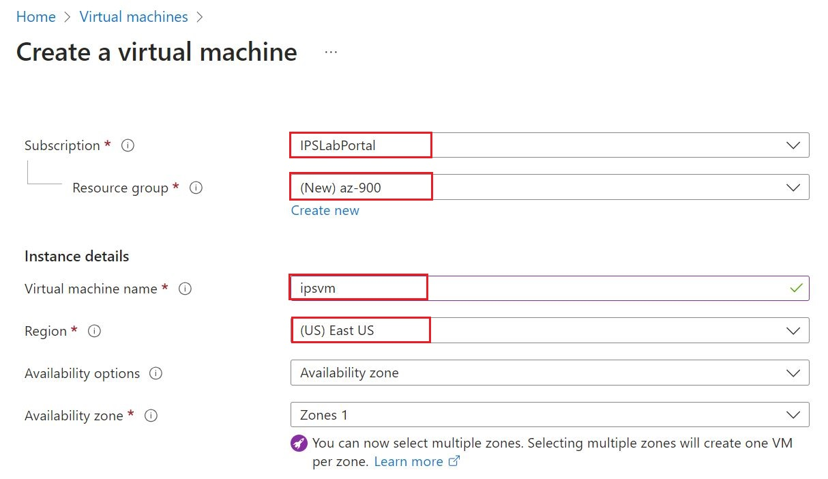

4. Verify or enter the following values for each setting. If a setting is not specified, leave the default value.

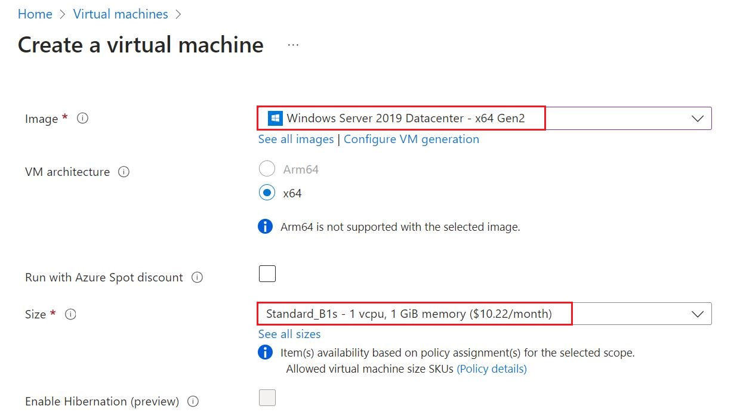

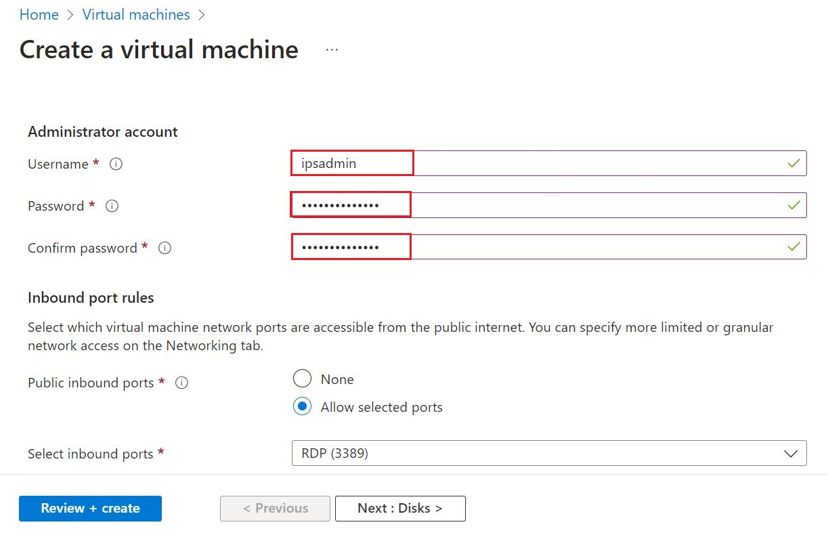

5. Select Review and Create.

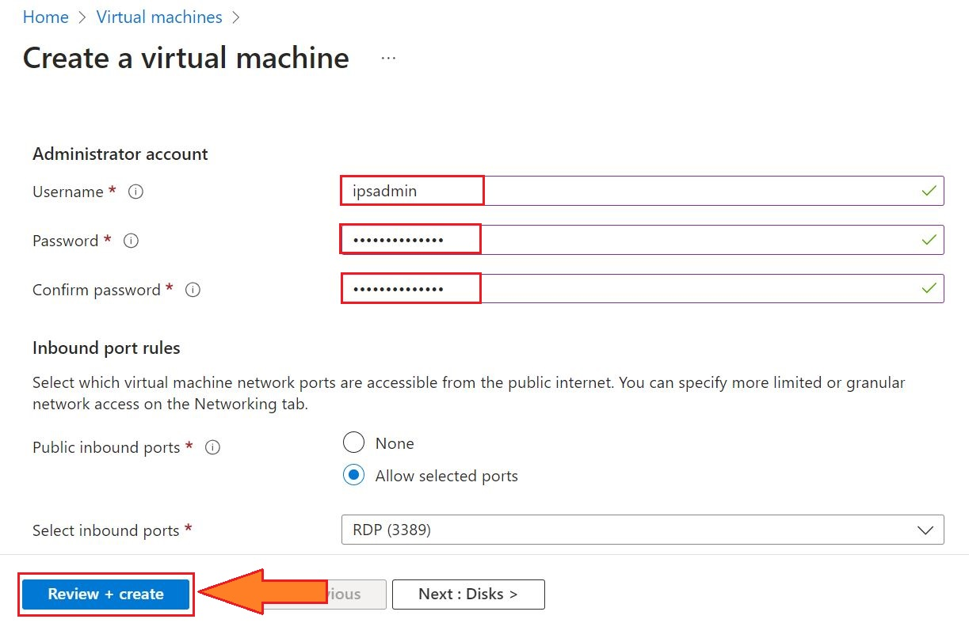

6. Select Create

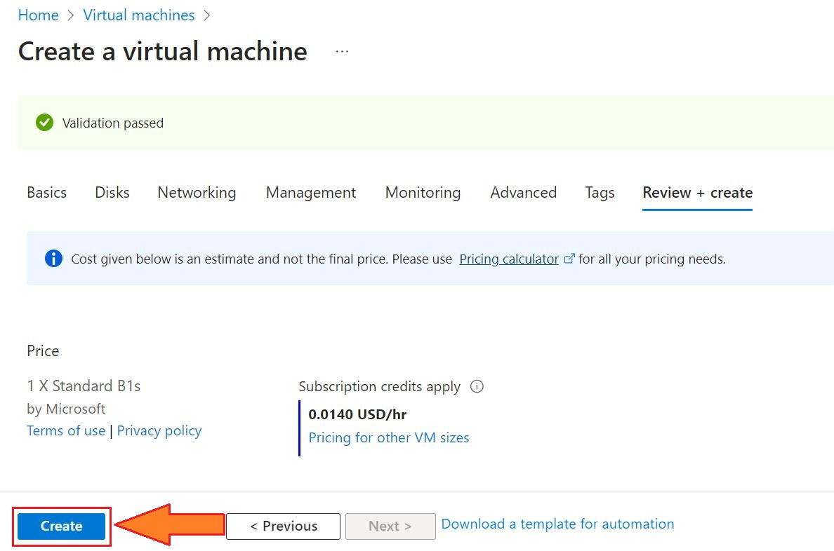

#### Task 2: Verify Resources Created

1. Select Home.



2. Select the resource group and open the vm you created.

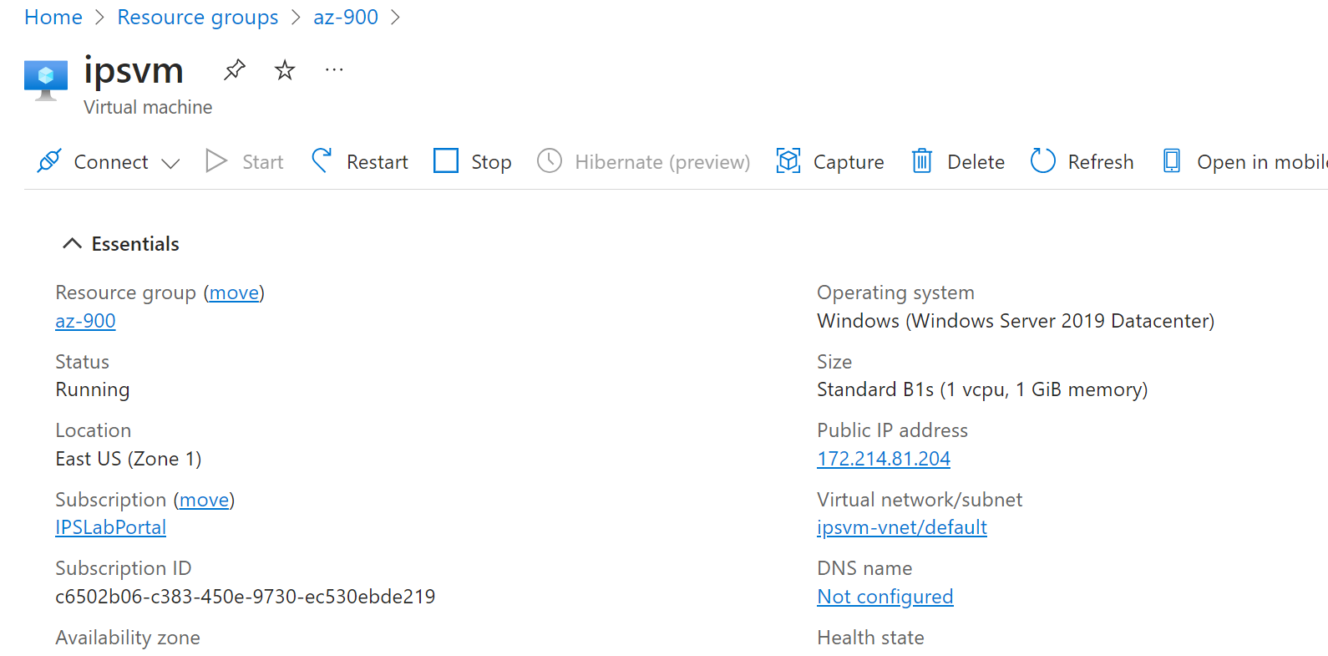

#### Task 3: Create a Linux Virtual Machine and Install Nginx

1. From Cloud Shell, run the command to create a Linux VM:

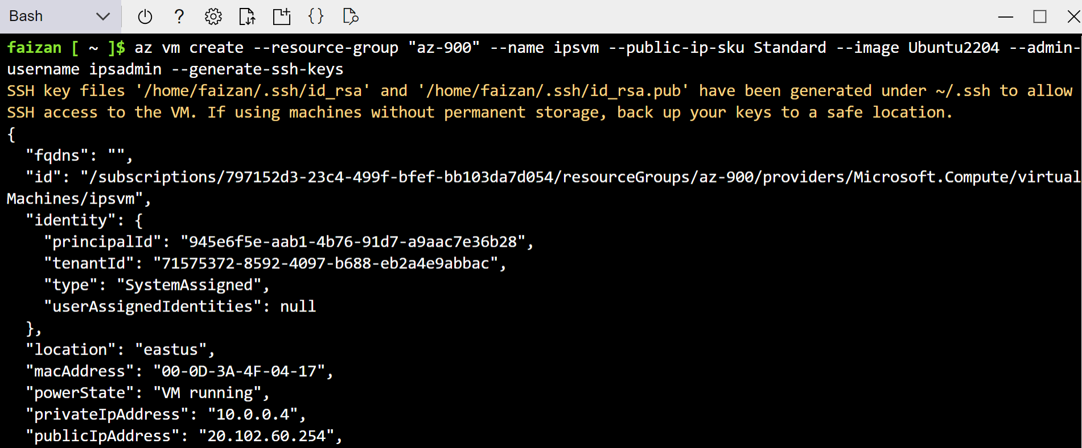

1. Run the following command to configure Nginx on your VM:

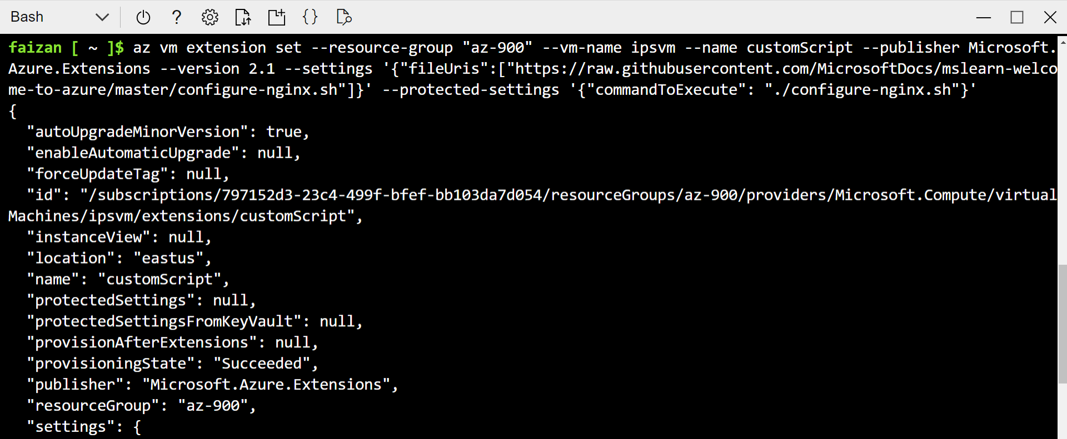

## Lab 2-02: Configuration of Windows Virtual Machine in Azure using RDP

### Service Introduction

In Azure, deploying a Windows Virtual Machine (VM) enables users to run Windows-based applications and services in the cloud environment. Leveraging Remote Desktop Protocol (RDP), users can securely connect to their Windows VMs, granting them remote access to the desktop interface for configuration, management, and application deployment. This flexibility allows businesses to efficiently scale resources, adjust performance parameters, and optimize workloads to meet specific requirements. The seamless integration of Windows VMs with Azure's ecosystem, coupled with the convenience of RDP, provides a robust and user-friendly solution for hosting Windows workloads in the cloud, enhancing accessibility and facilitating streamlined management processes.

### Problem

An organization wants to find a solution to process the data stored in the same format from different applications built on a virtual machine.

### Solution

The organization can use the Windows virtual machine and store the incoming data in the same format through the Azure function. This lab is divided into two sections.

* Create and configure a virtual machine in Azure
* Connect Windows Azure virtual machine using Remote Desktop Protocol (RDP)

1. Log in to the **Microsoft Azure portal** and go to the portal menu.

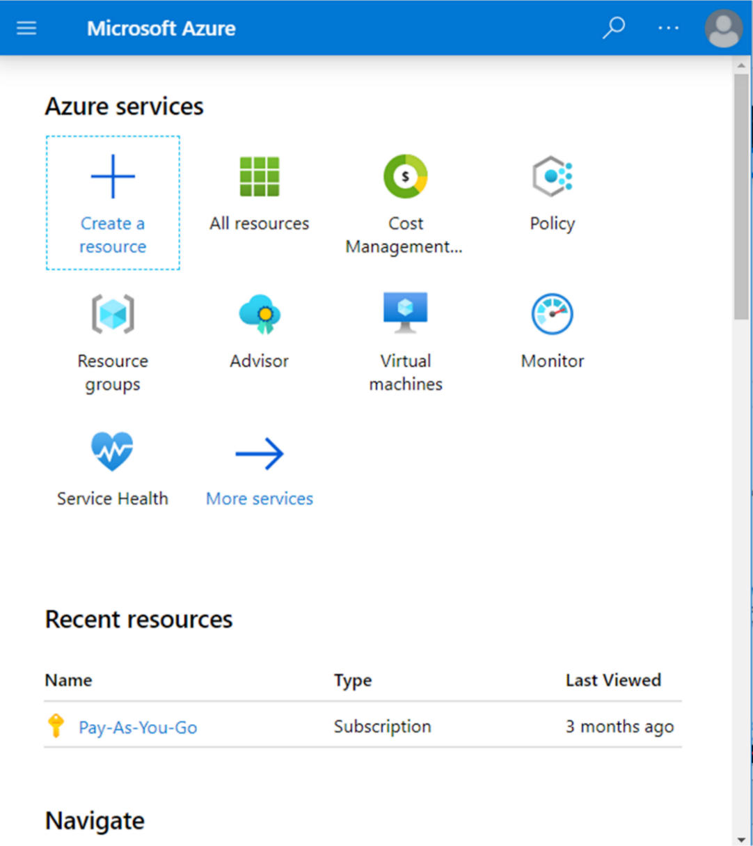

1. Go to the main menu and click on “**Create a resource.**”

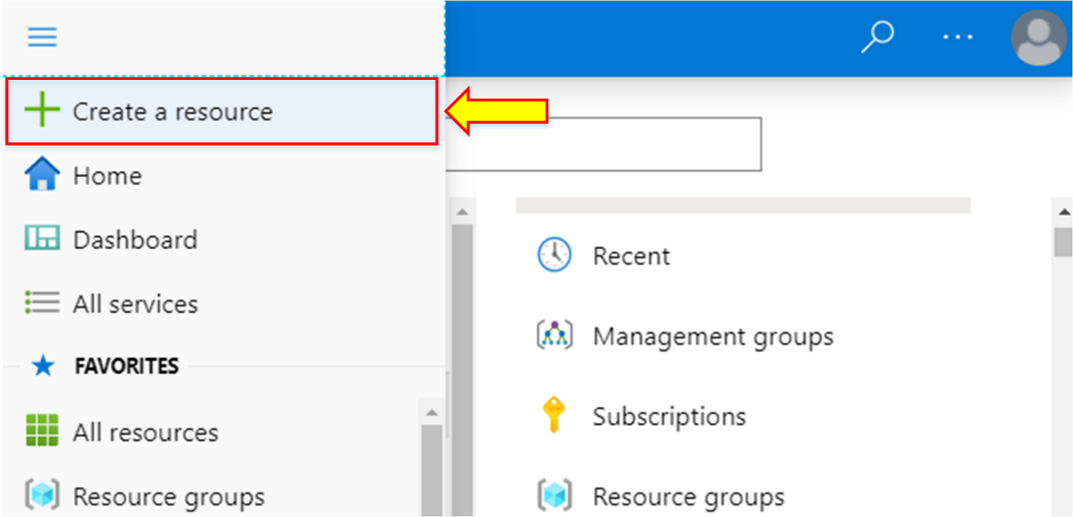

1. Type “**Windows Server**” in the search box and click “**Enter**.”

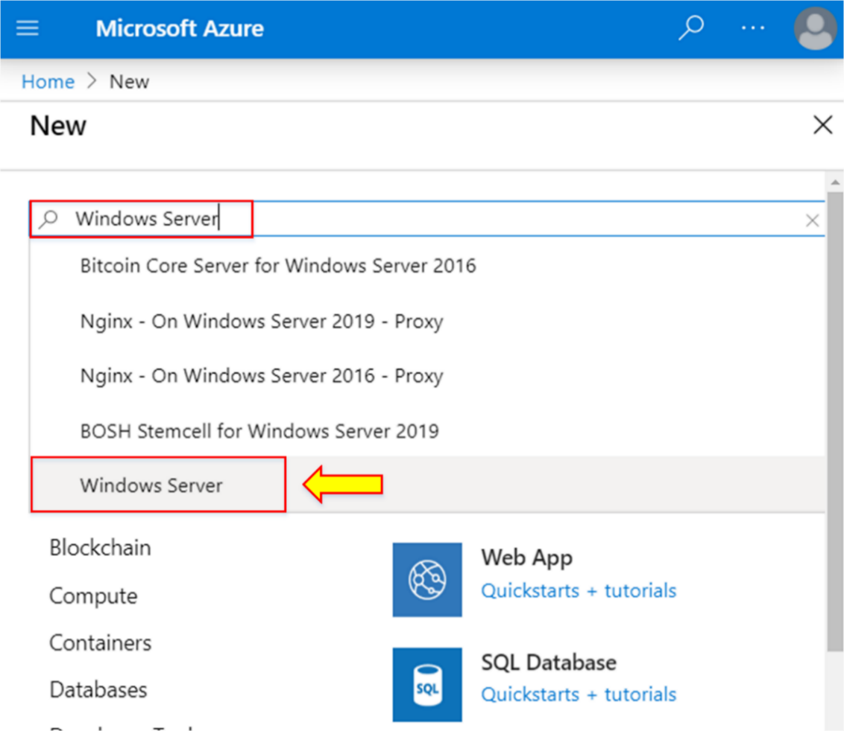

1. Click on “**Select a software plan**” and find **“[smalldisk] Windows Server 2019 Datacenter with Containers”** from the list.

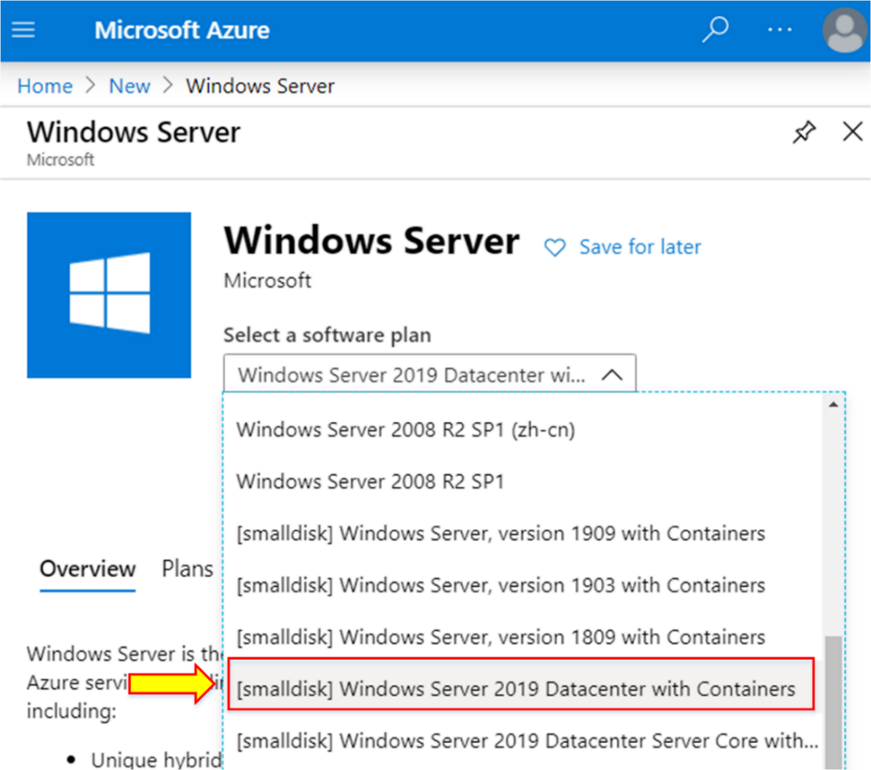

**Note:** You can also use other Windows Server versions to create a virtual machine.

1. Click on “**Create.”**

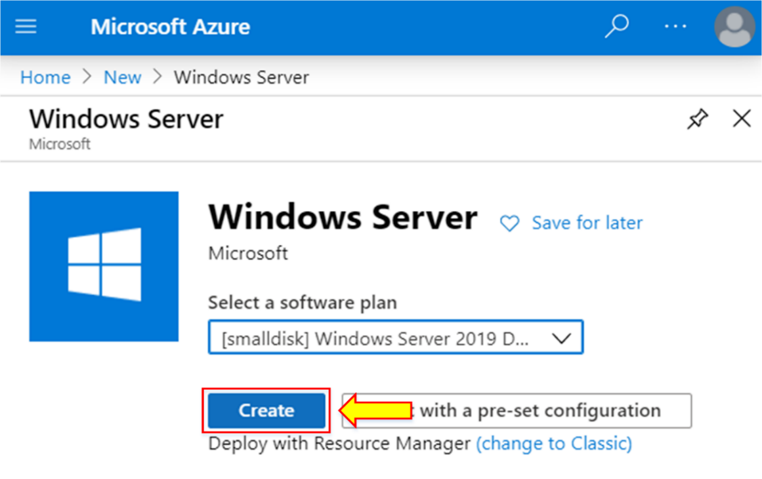

1. After that, configure the virtual machine settings.
2. Choose an available resource group.

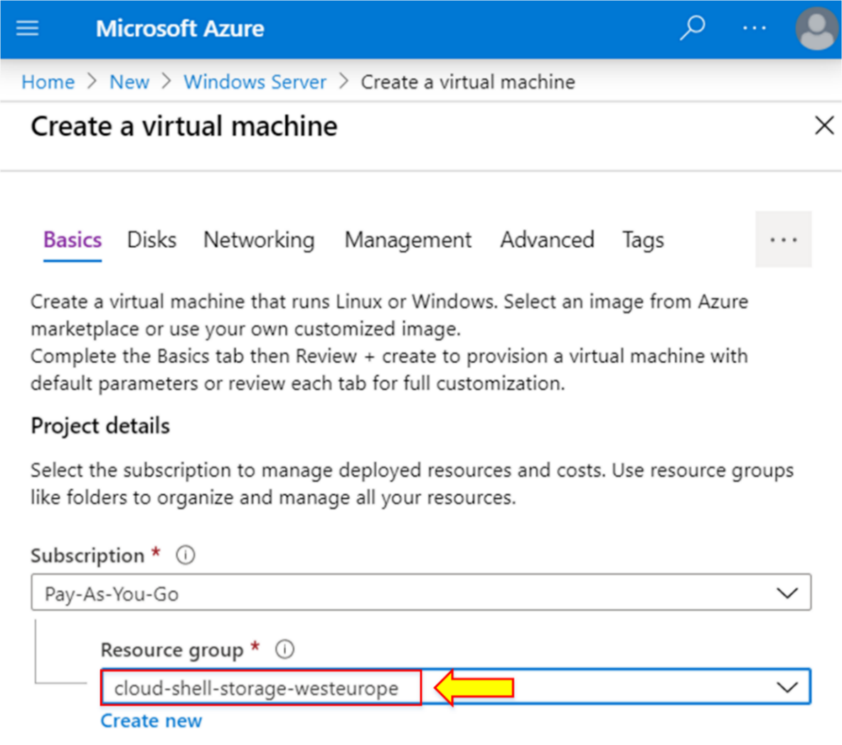

1. Name the virtual machine “**ipsvm.”**

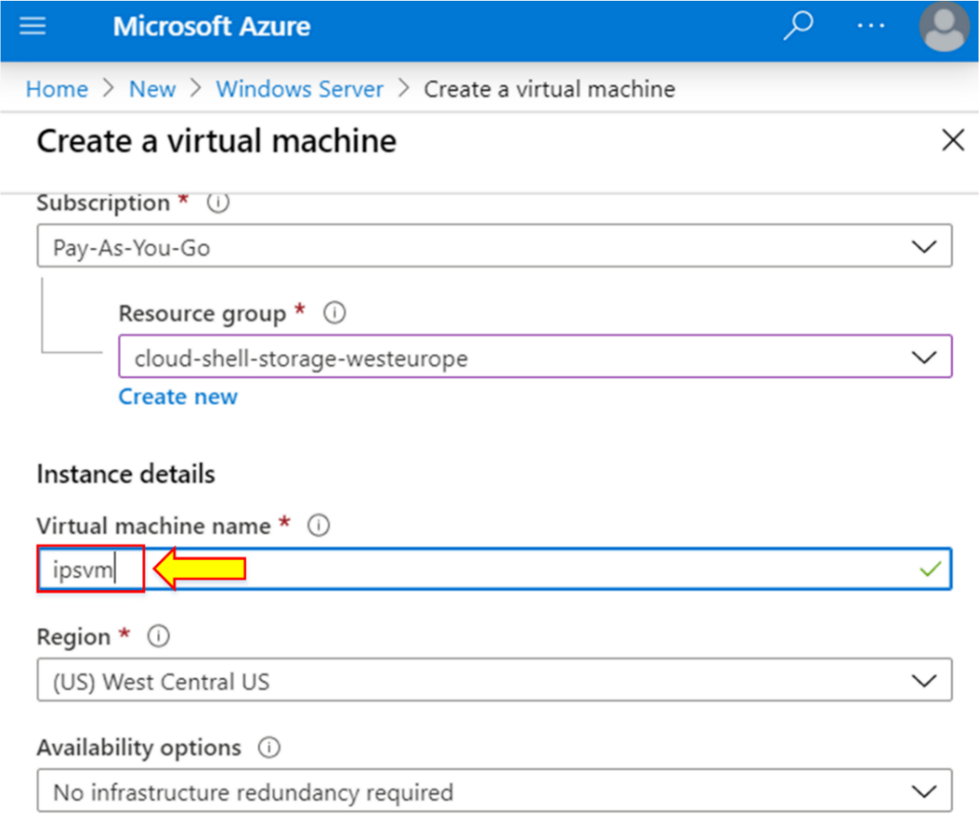

1. Select the VM image of the same Windows Server version.

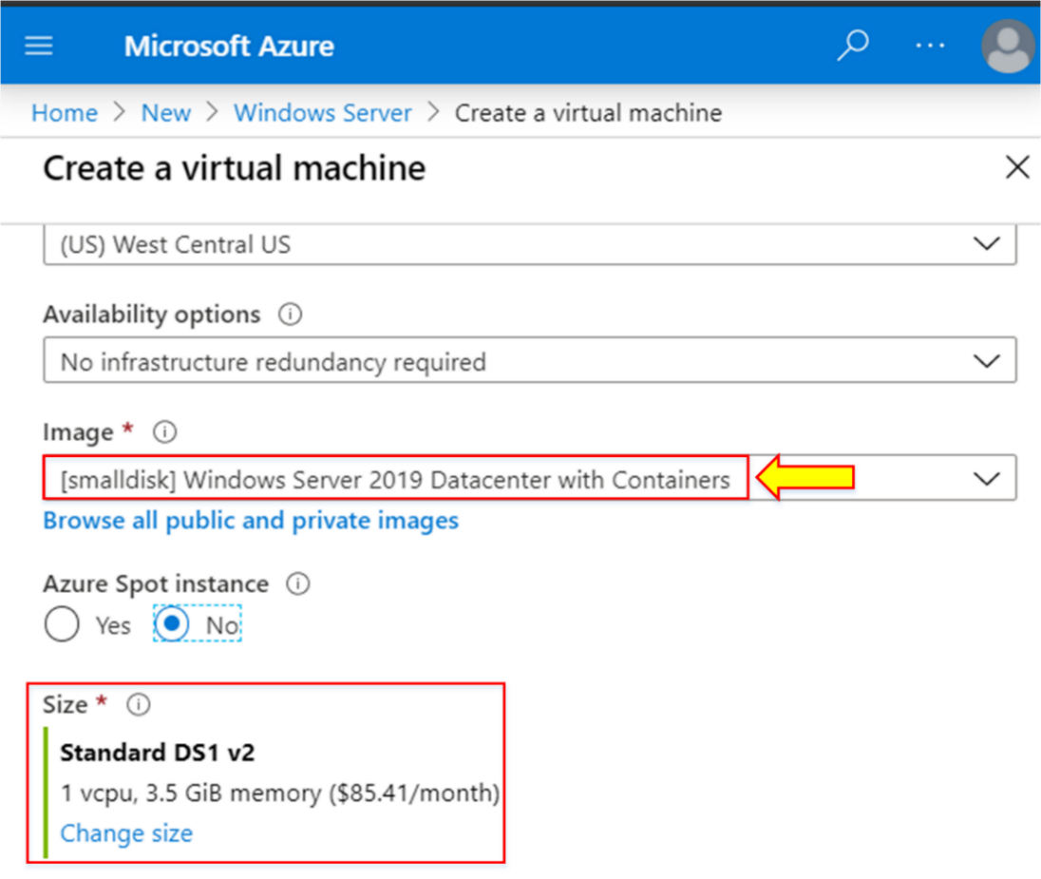

**Note:** The size of the VM will be Standard DS1 v2.

1. Fill in the “**Administrator account**” details.

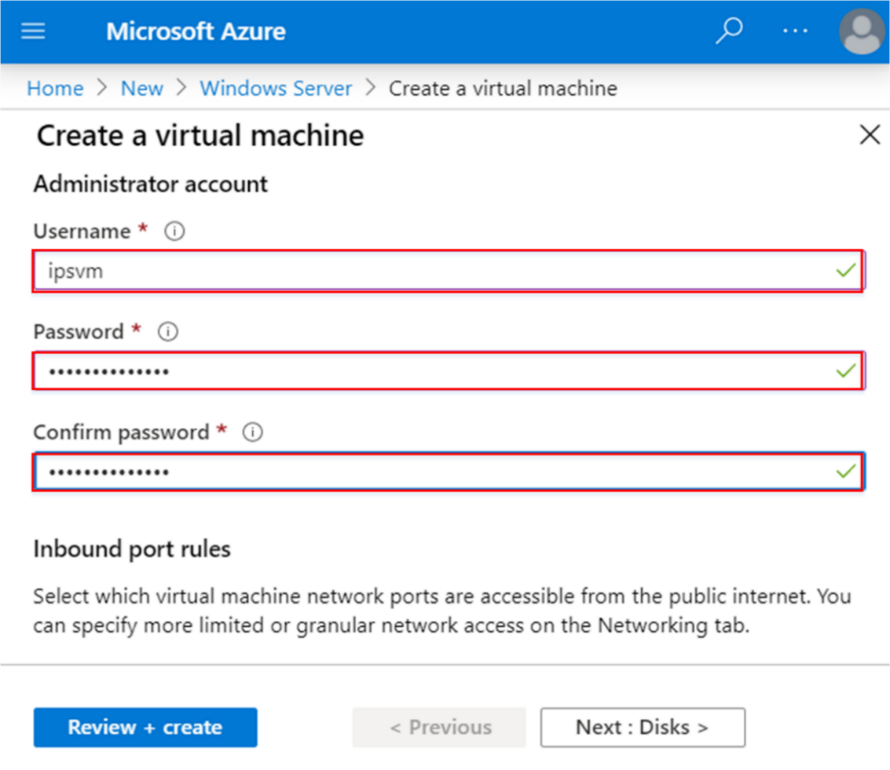

**Note:** Use “**ipsvm”** as a “**Username.”**

1. Select “**RDP (3389**)” as an inbound port rule.

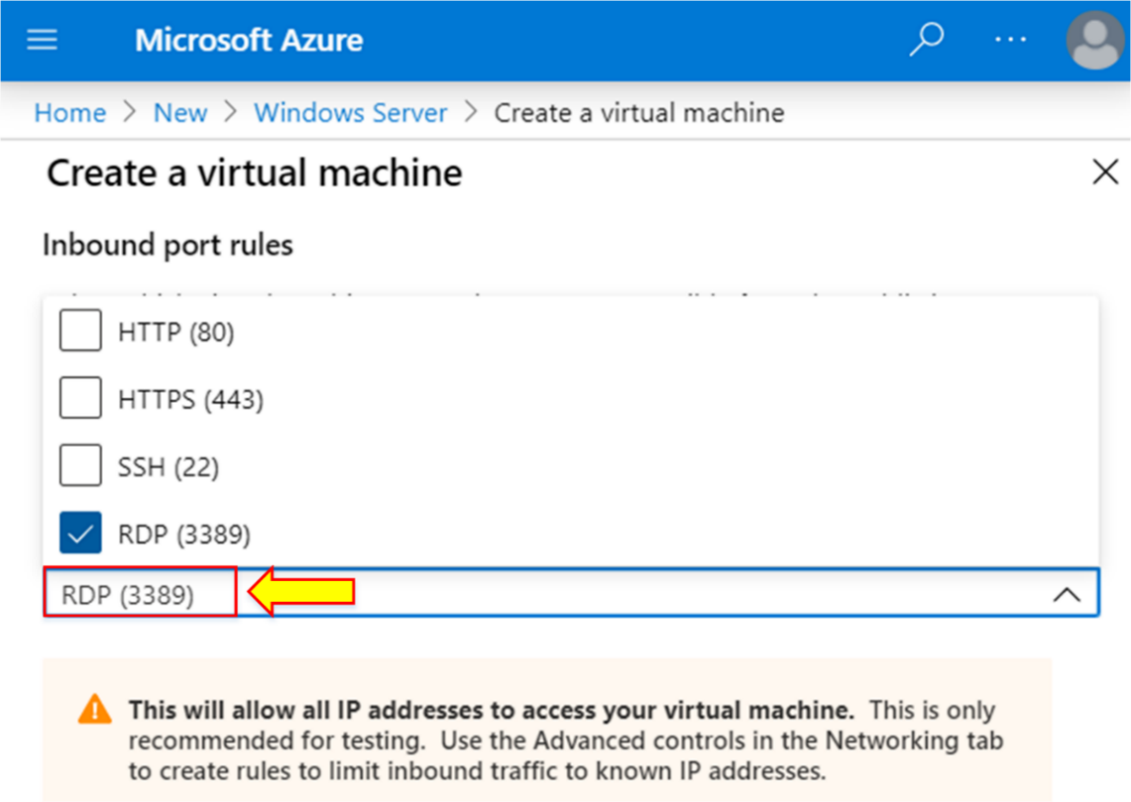

1. Click on **“Next : Disk >.”**

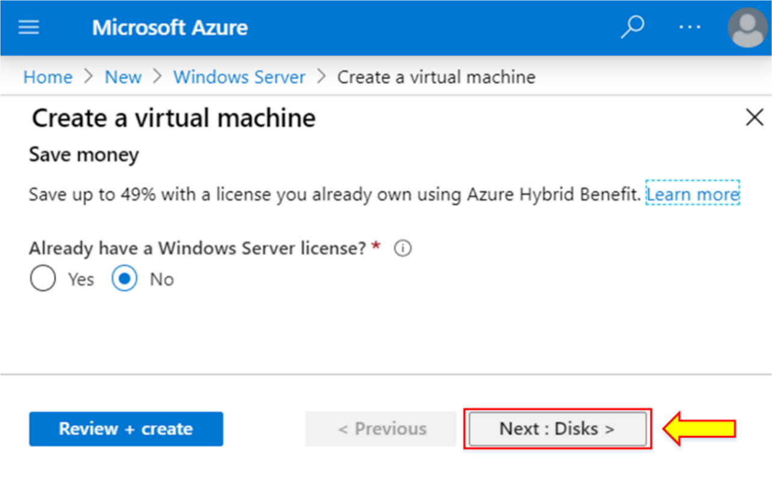

1. Choose “**Premium SSD”** as an OS disk type.

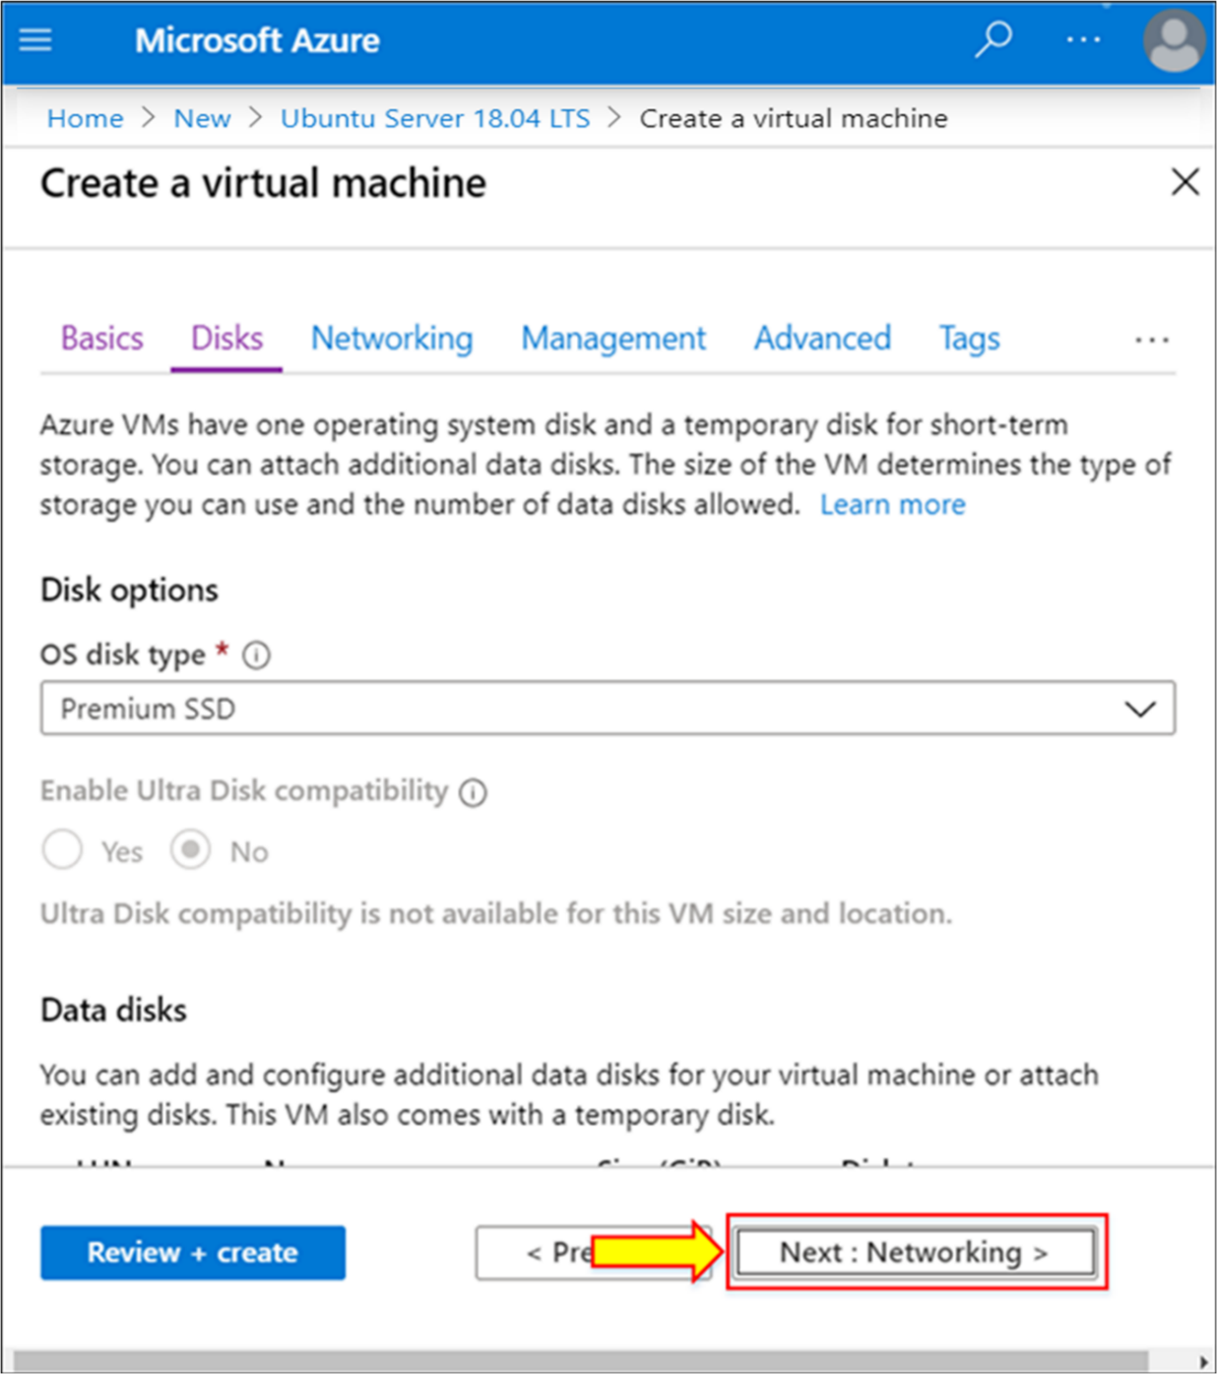

1. Click on “**Create and attach a new disk.”**

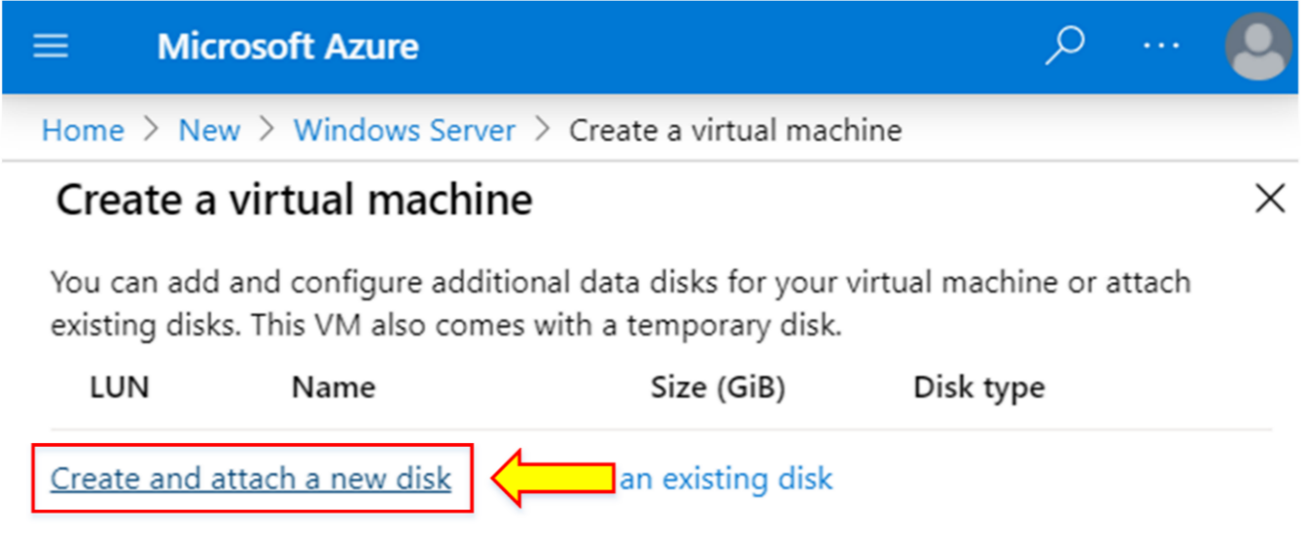

**Note:** OS disk type will give C: and temporary D: drive. You will have to create and attach a new disk to add a new data drive.

1. Set the name of the new data disk as “**ipsvm_DataDisk_1”.**
2. Then, click on “**OK.”**

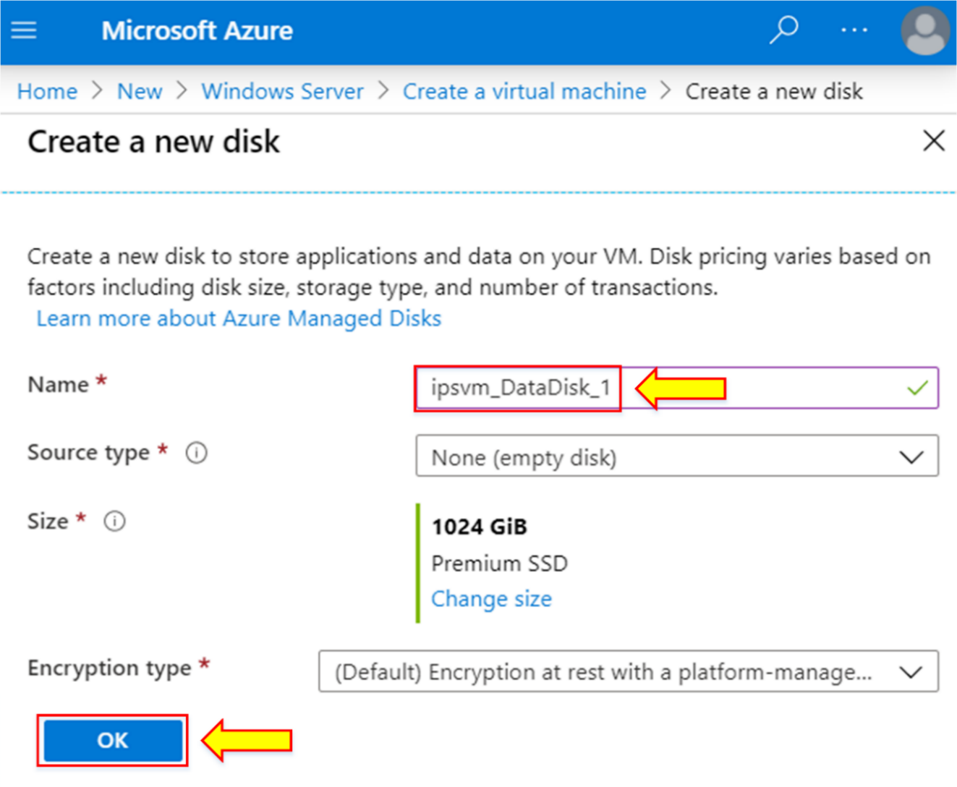

1. You will see the created new data disk with a size of 1024 GiB.
2. Click on “**Next: Networking >.”**

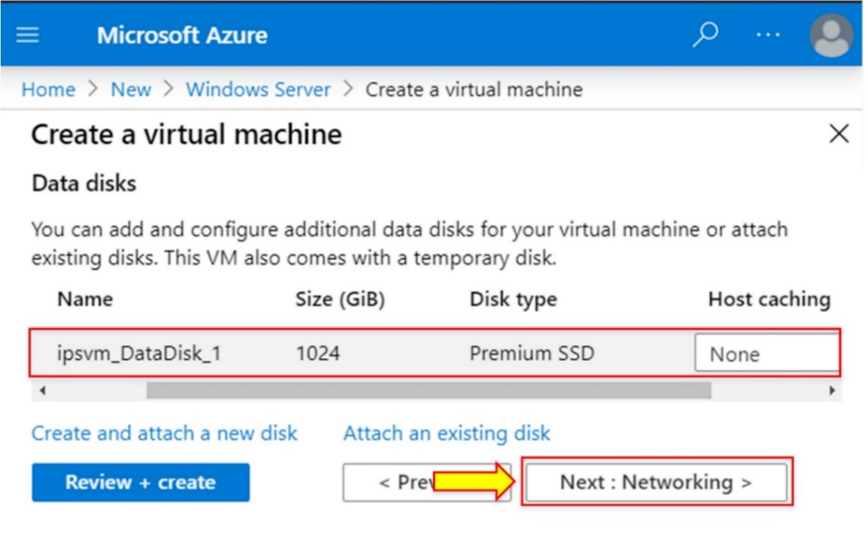

**Note:** Dedicated data disks are generally considered the best place to store application data files. They can be larger than OS disks, and you can optimize them for the cost and performance characteristics appropriate for your data.

1. Configure a new Virtual Network (VNet).
2. Click on “**Create new.”**

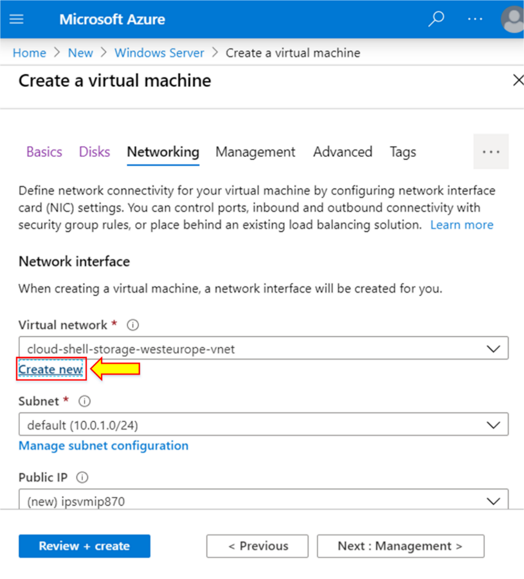

1. Set name as **“ipsvnet.”**
2. Give the address space of **“172.16.0.0/16”.**

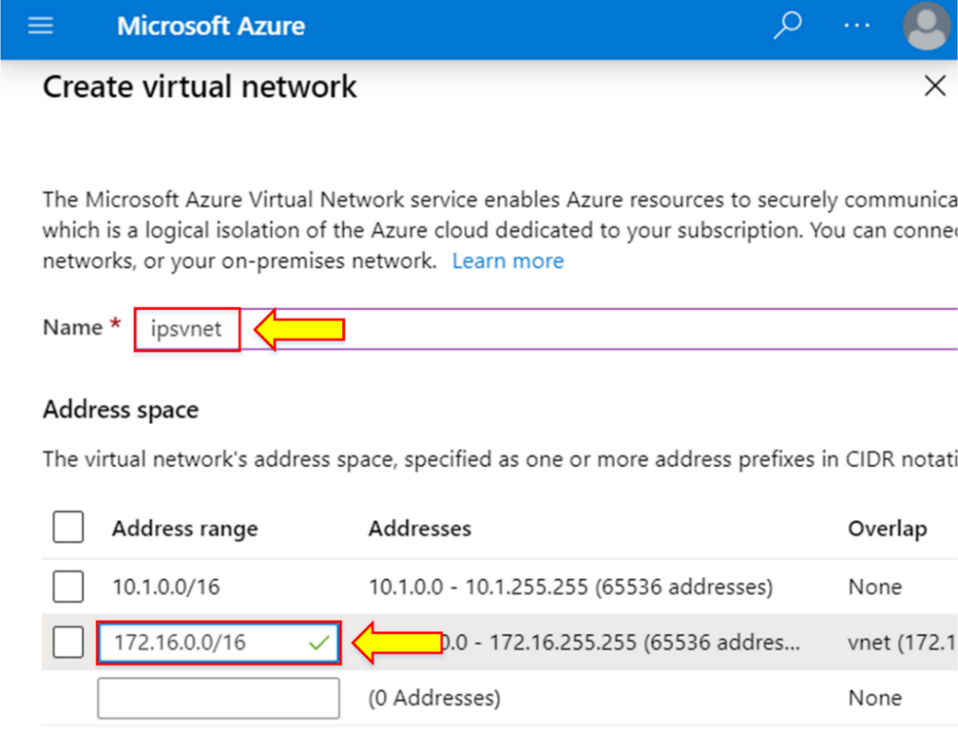

1. Write the subnet name as “**subnet”** and the address range of **“172.16.1.0/24.”**
2. Click on “**OK.”**

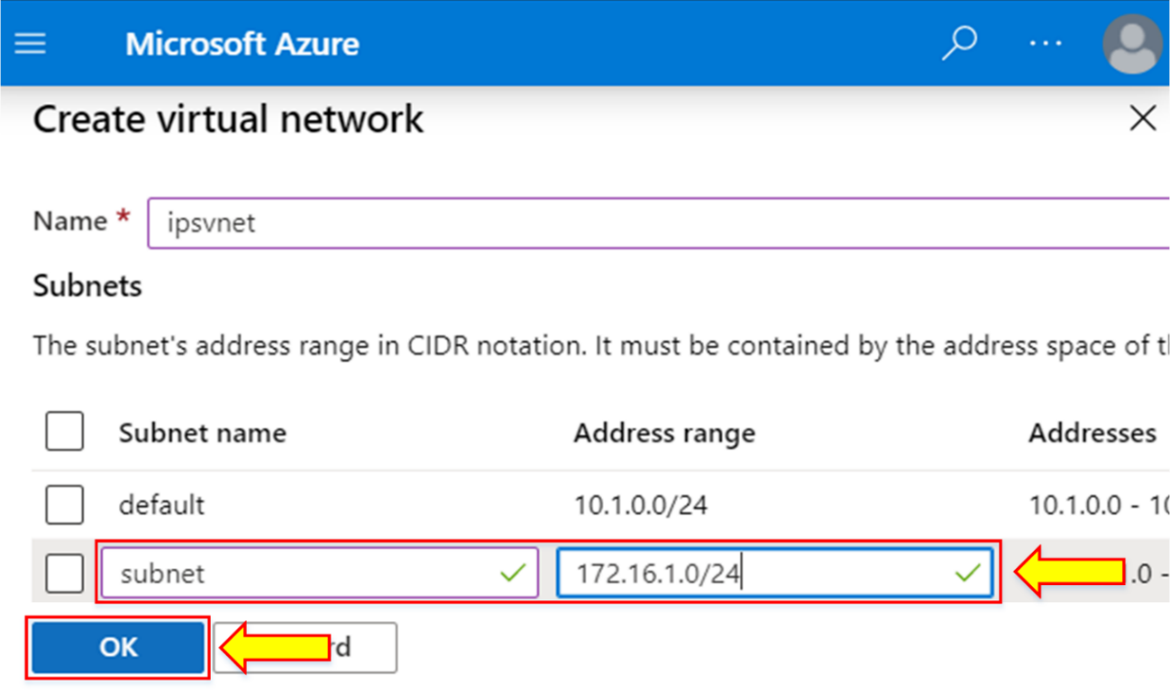

1. Click on “**Next : Management >”.**

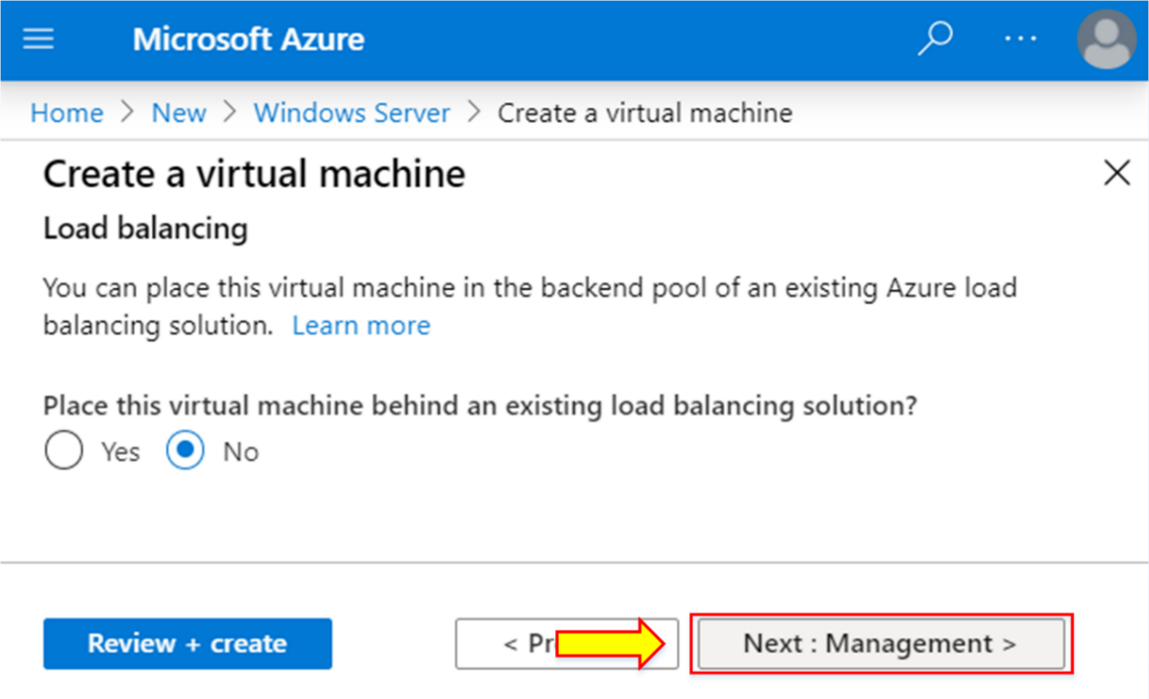

1. Click on **“Create new”** for the configuration of the storage account.

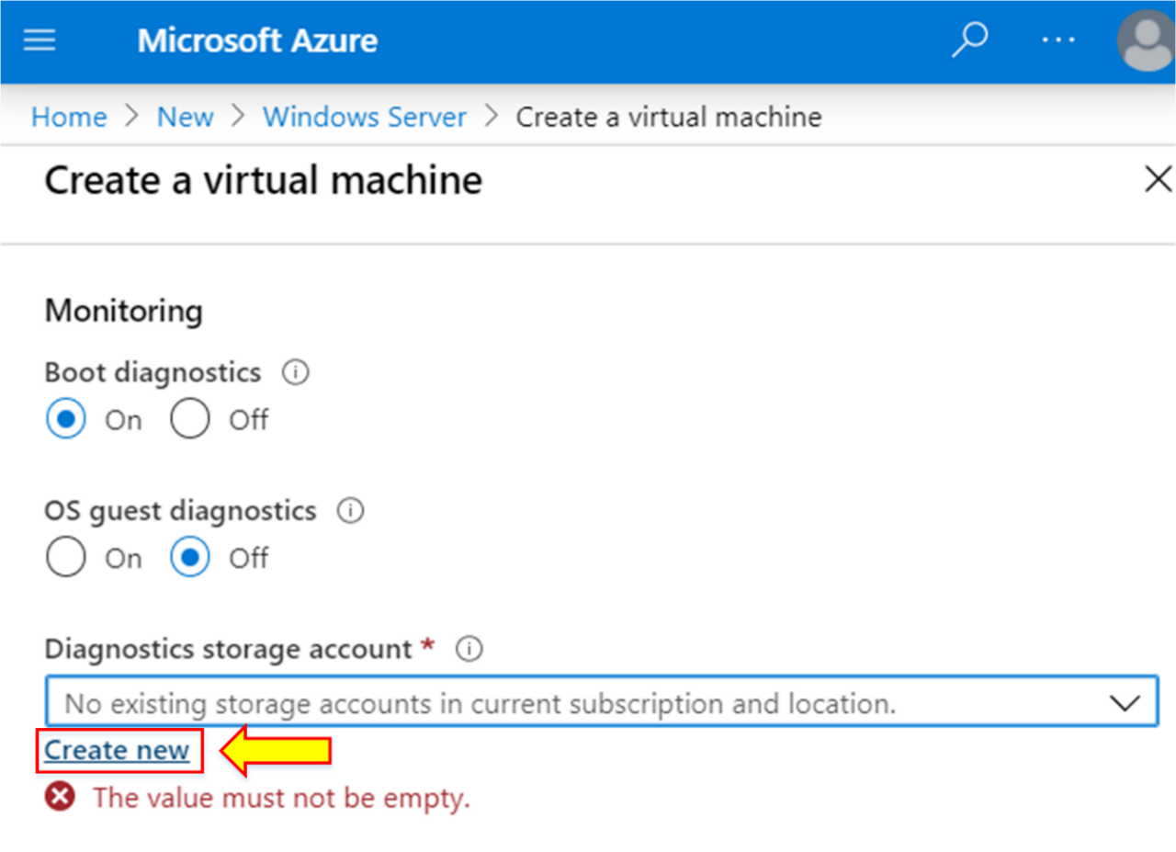

1. Write the name of the storage account as **“ipsvm.”**
2. Click on “**OK”.**

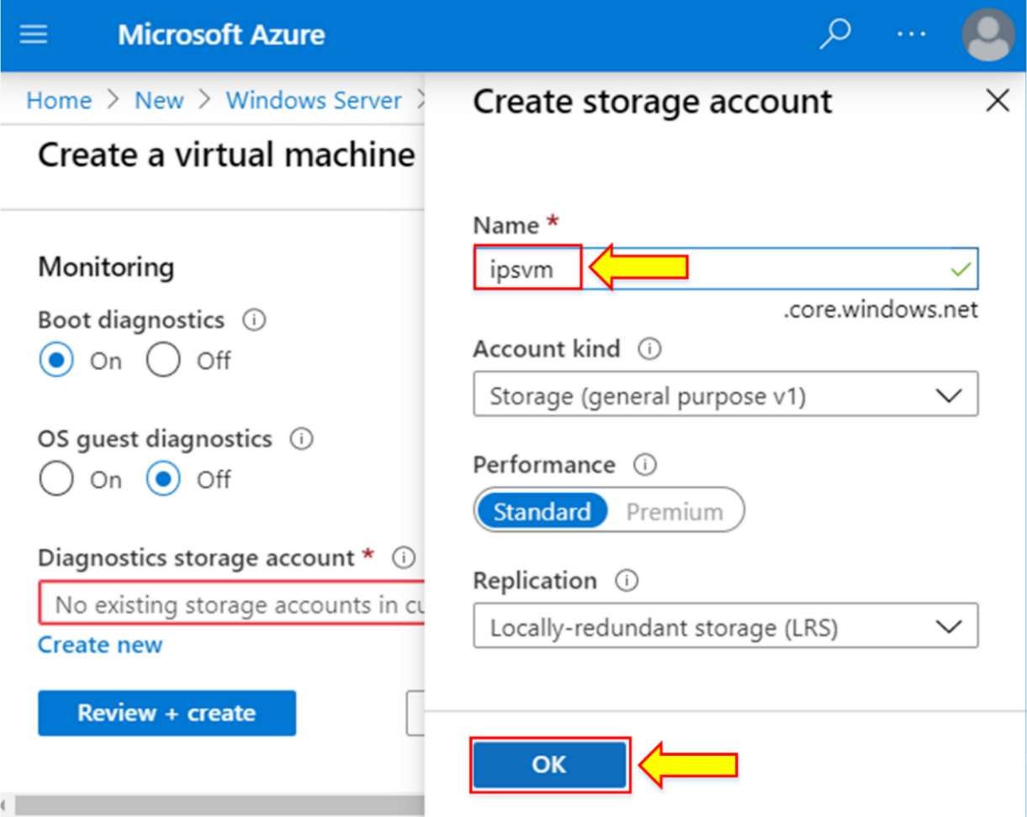

1. Click on “**Next : Advanced >”.**

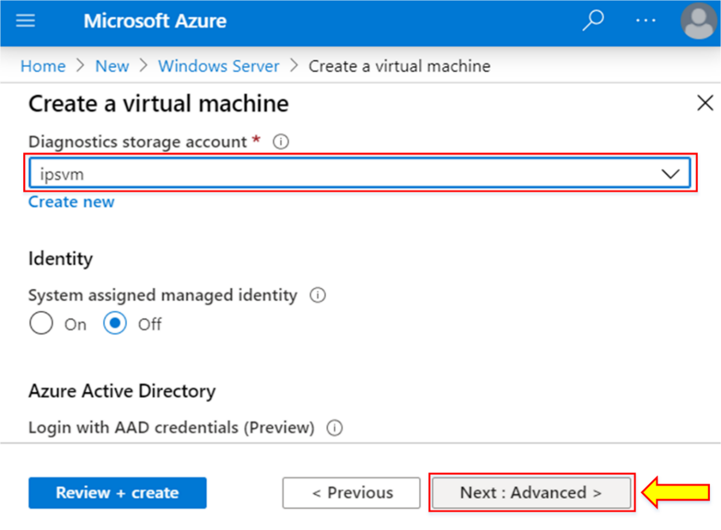

1. Click on “**Next : Tags >”.**

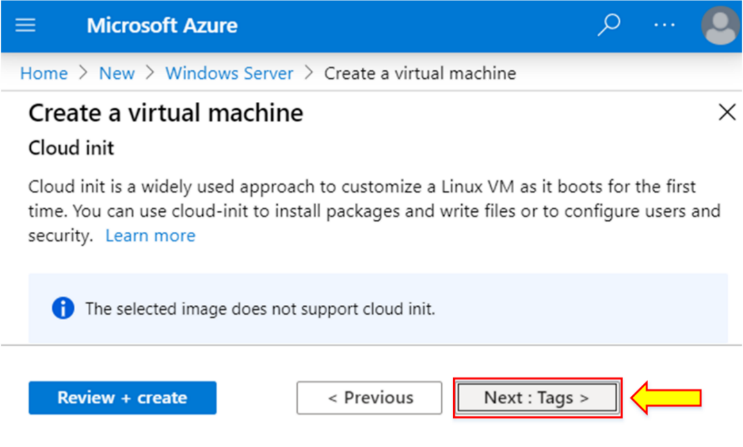

1. When the validation is passed, click on “**Create.”**

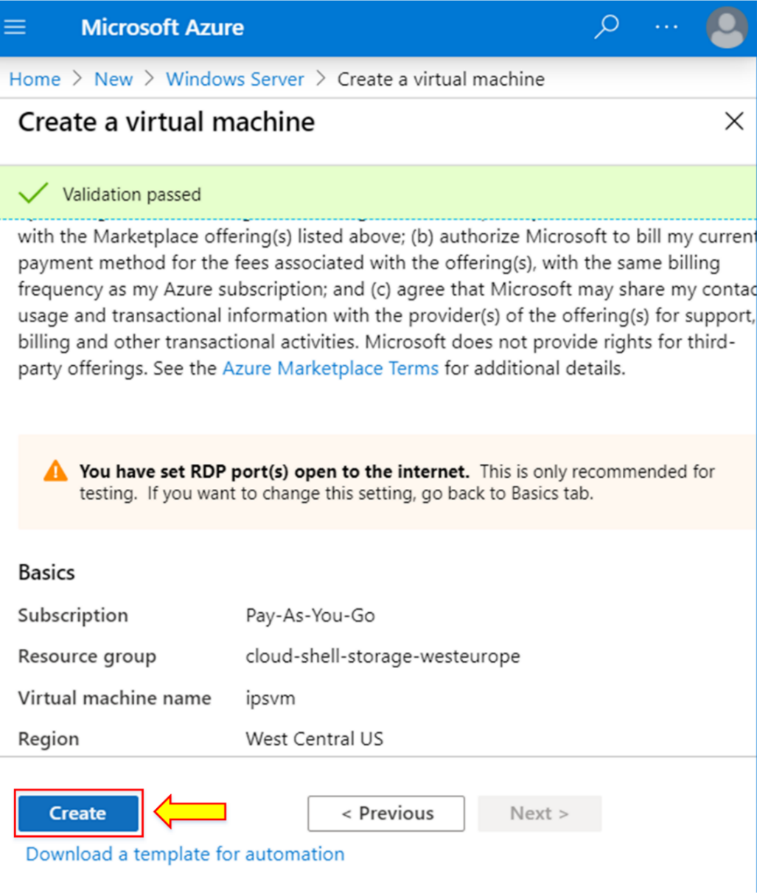

1. When all the deployment is done, click on “**Go to resource.”**

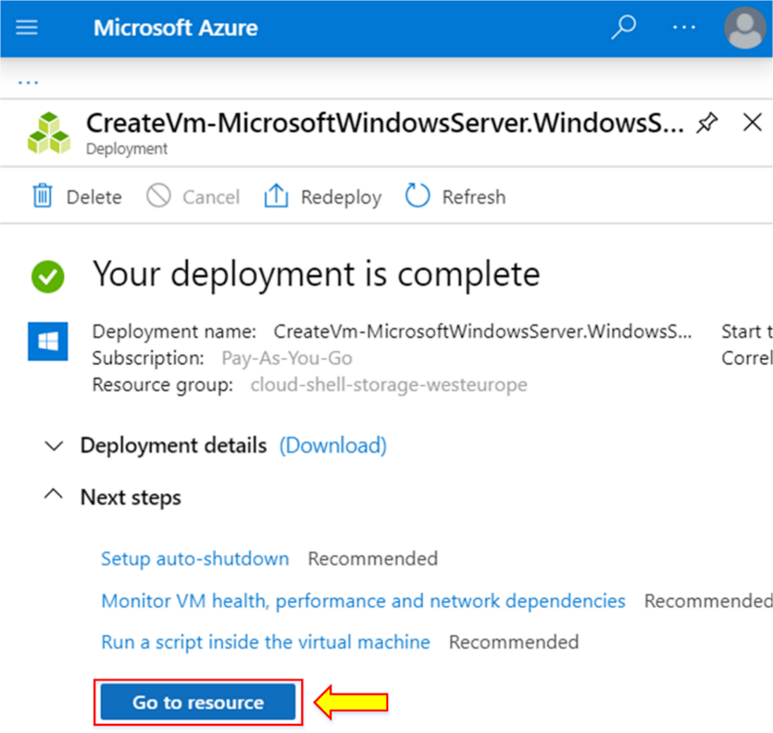

1. The configured Windows virtual machine is shown.

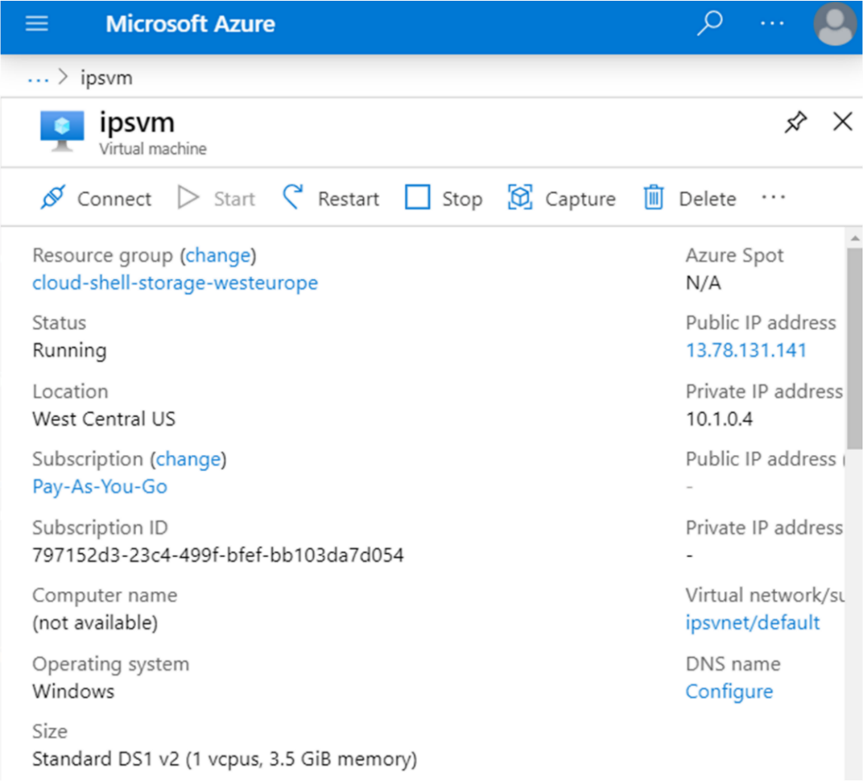

1. Search “**Remote Desktop Connection**” from the start menu.

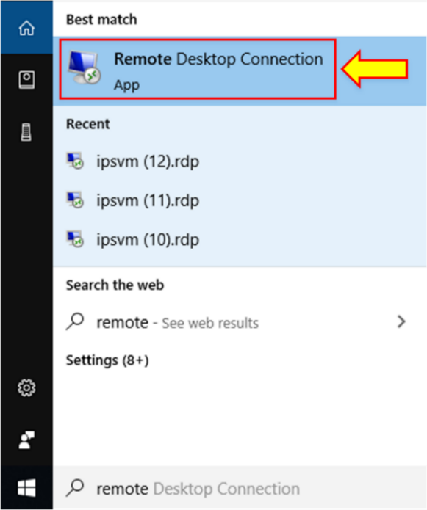

1. Enter the computer name/IP address and username.
2. Enable “**Allow me to save credentials.”**
3. Click on “**Save As.”**

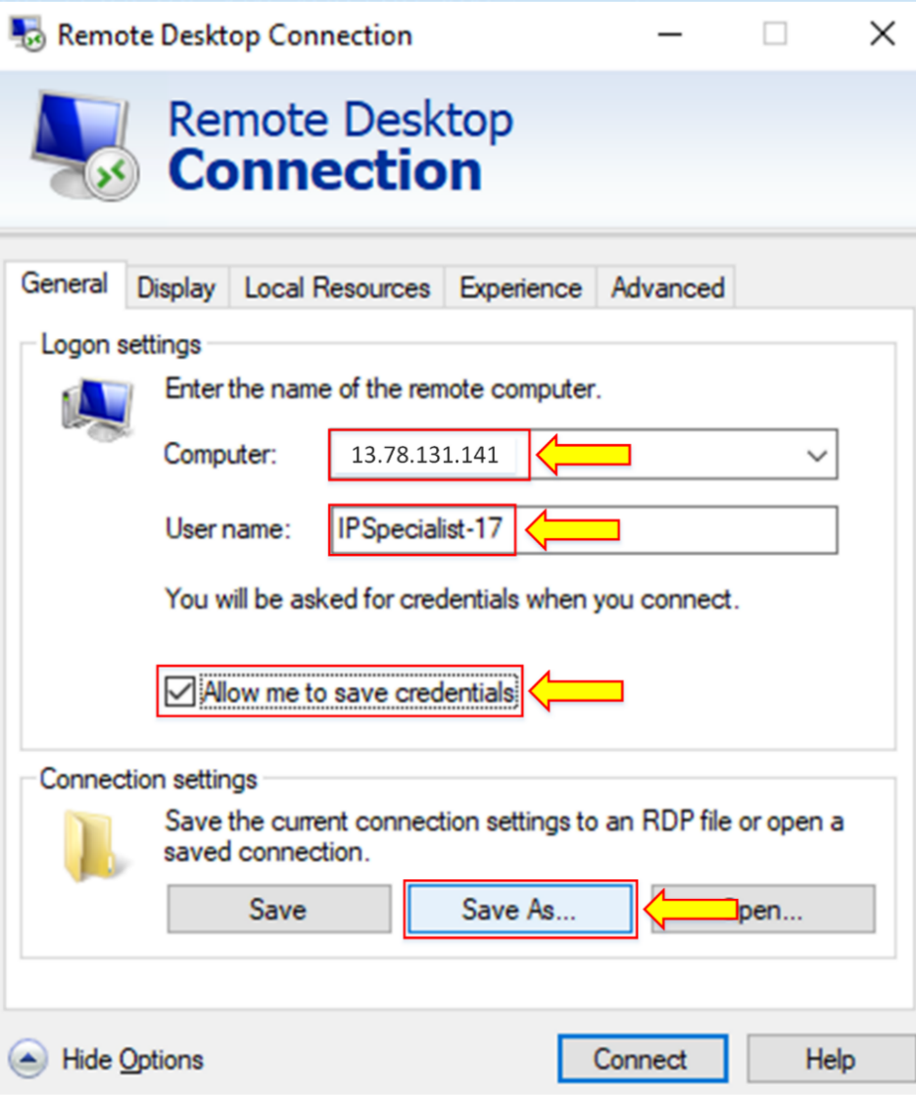

1. Save the file with the name “**ipsvm.”**
2. Click on “**Save”.**

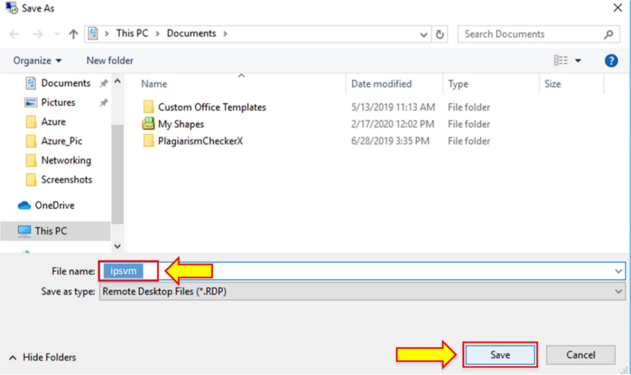

1. Go to the “**Local Resources**” section.

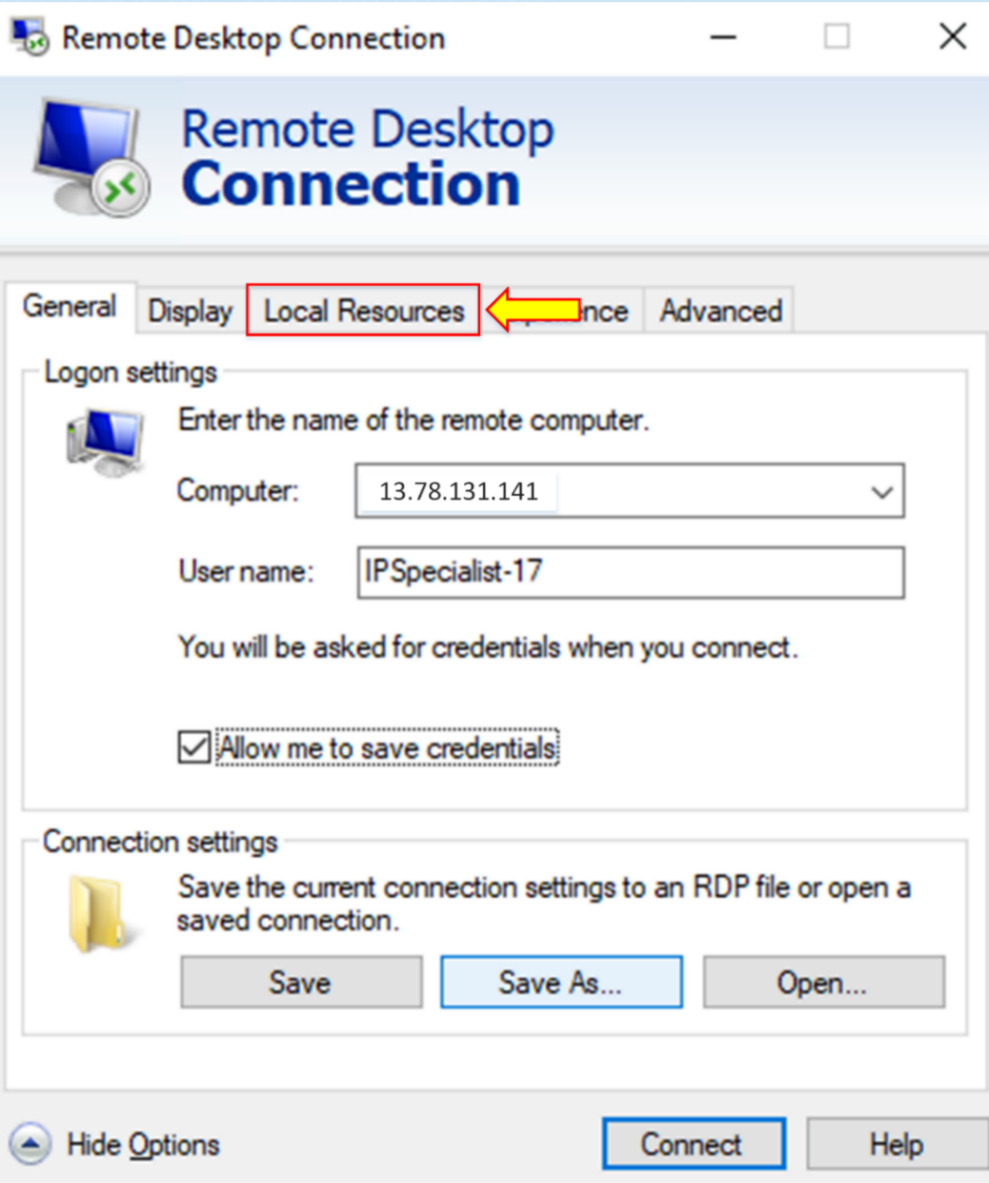

1. Click on “**More**”.

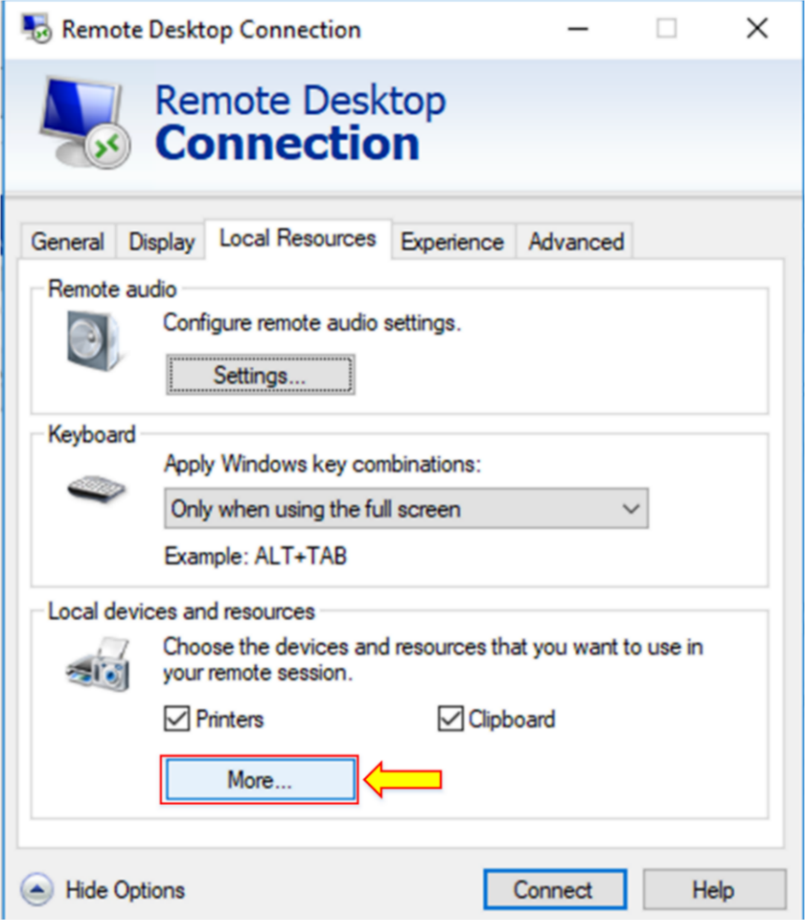

1. Enable all **“Drives**,” click on “**OK.”**

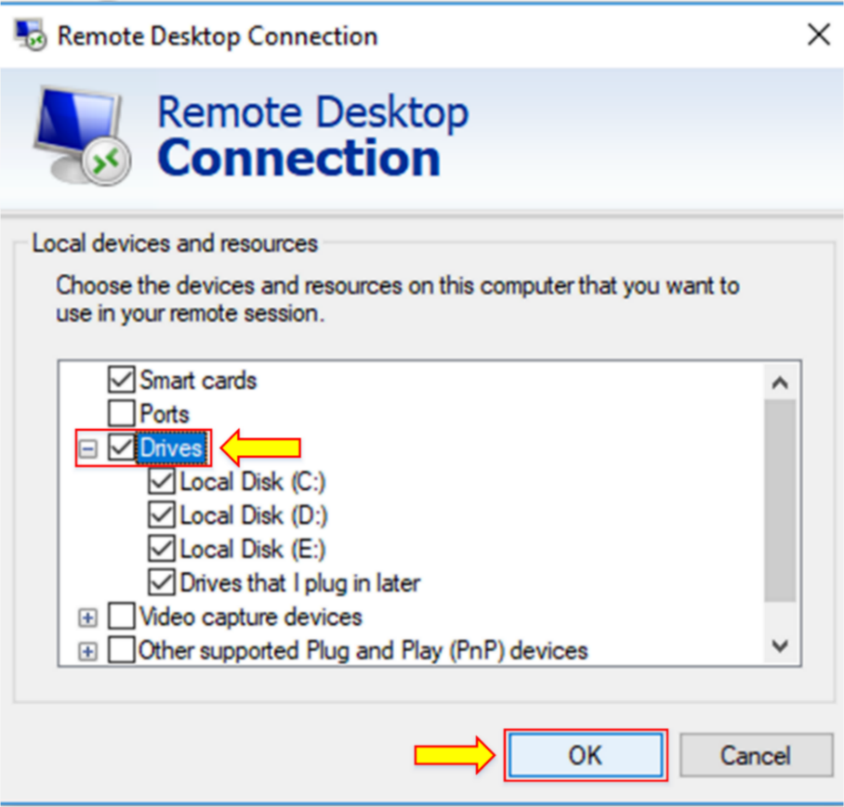

1. Go back to the “**General”** section. Then, click on “**Save.”**

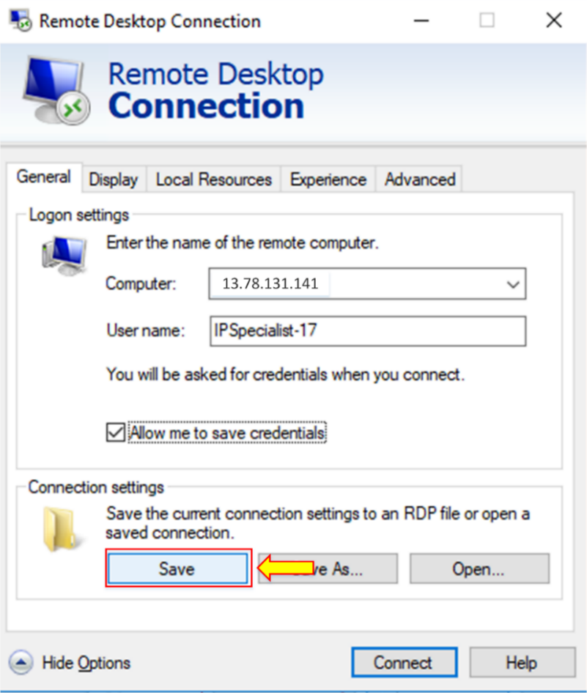

1. Now, click on “**Connect.”**

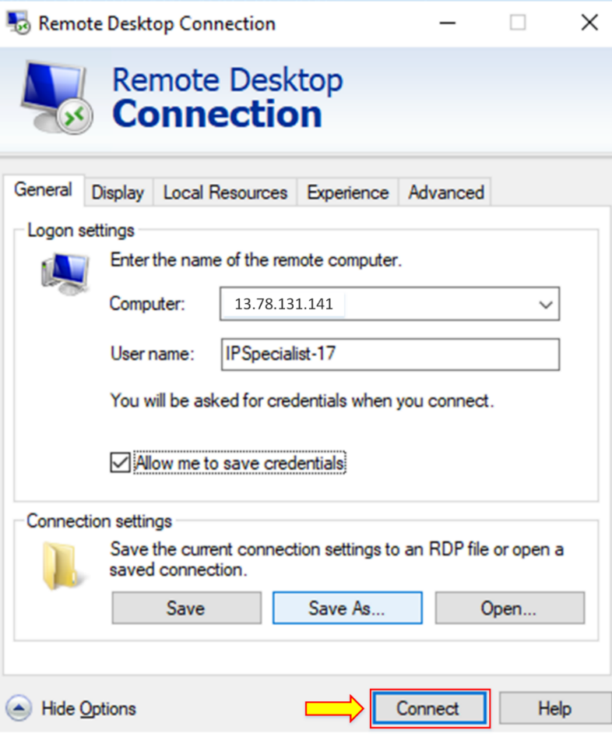

1. Now, go to the configured Windows virtual machine and click “**Connect.”**
2. Choose the “**RDP**” connection.

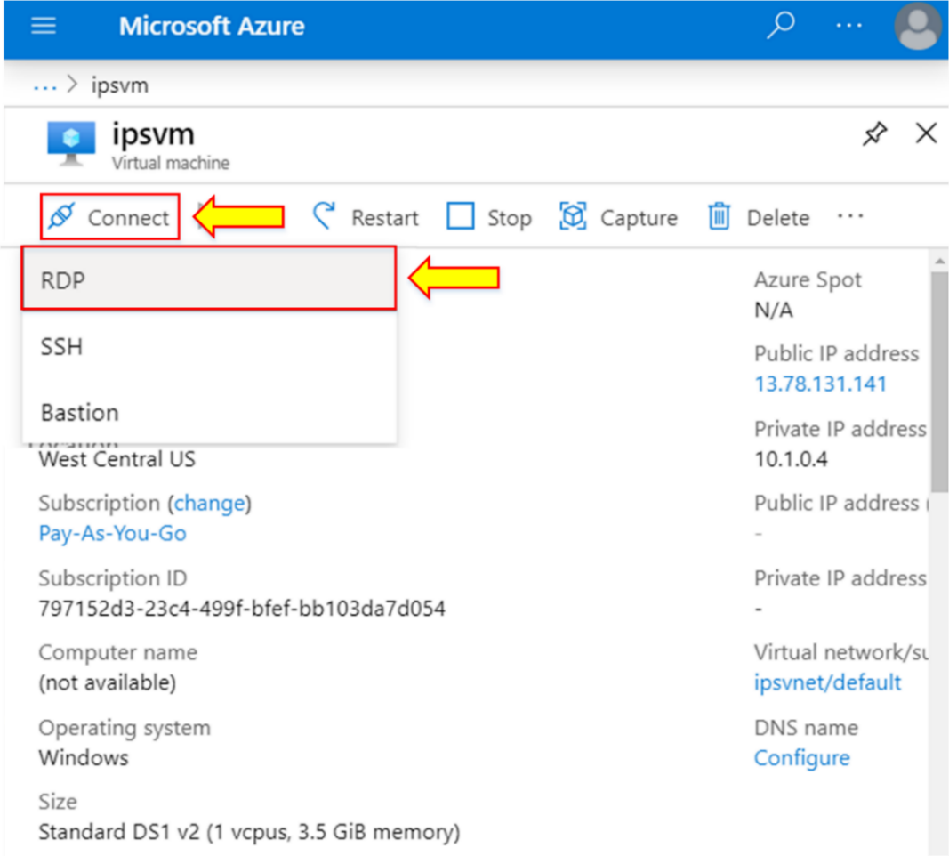

1. Note the IP address and port number.
2. Download the “**RDP**” file.

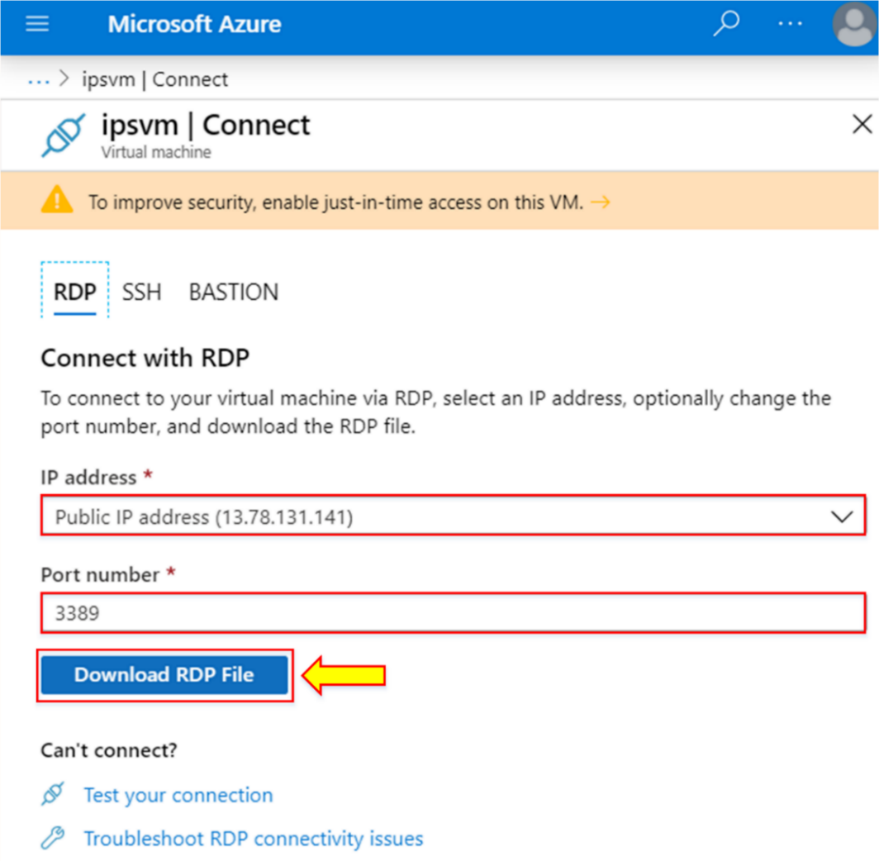

1. Click on “**ipsvm.rdp**” file.

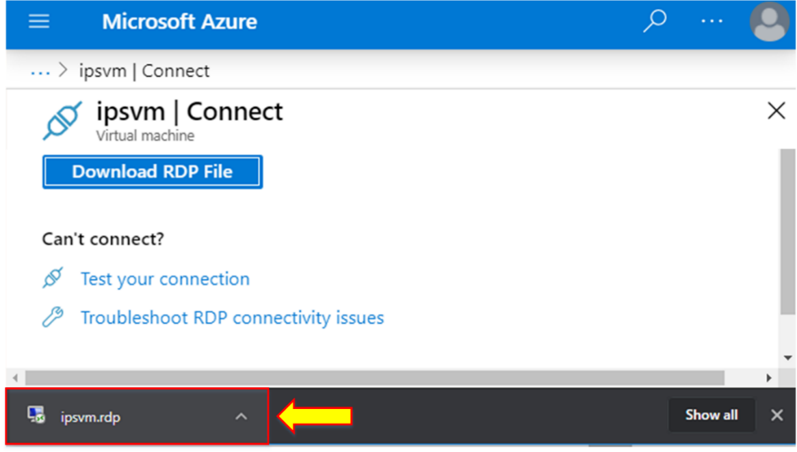

1. Click on “**Connect**.”

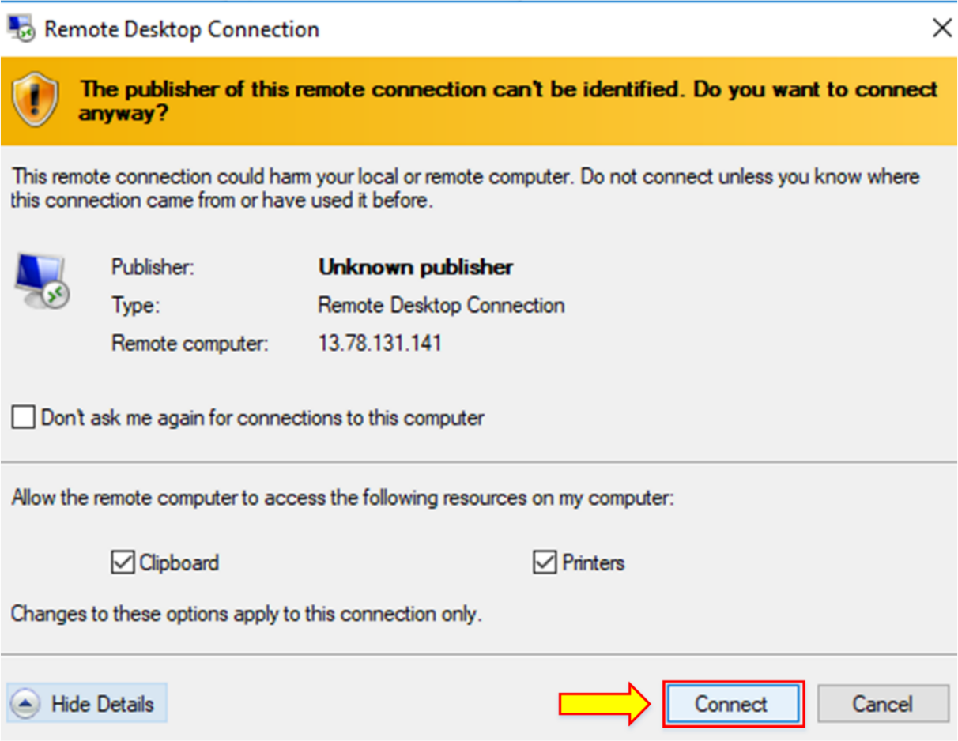

**Note:** When you click on “**Connect**,” you will receive an error.

1. Click on **“Hide Details.”**
2. Click on “**View certificate.”**

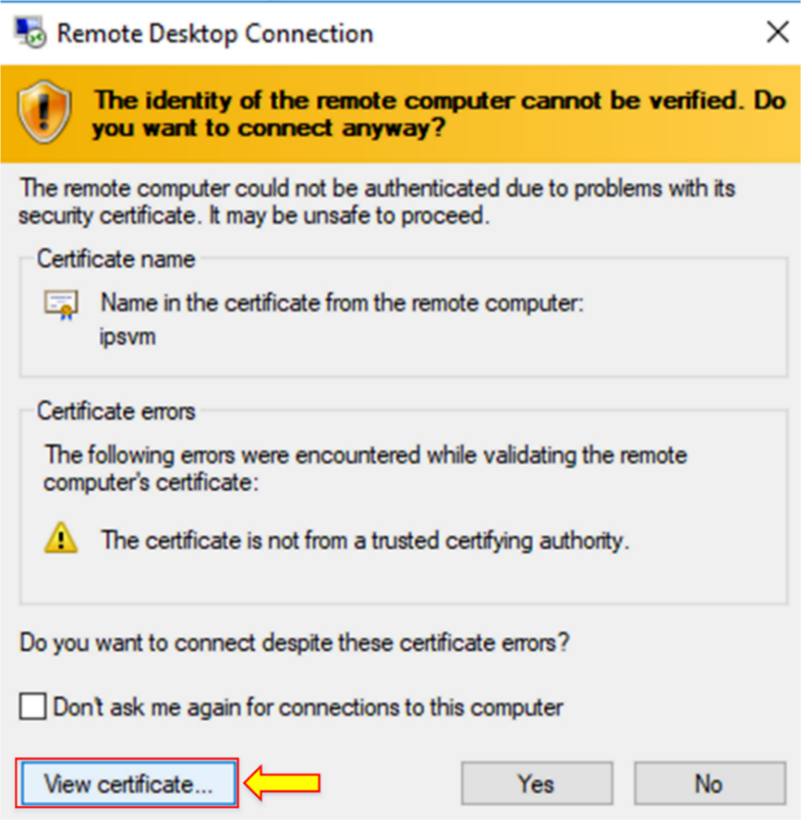

1. Click on “**Install Certificate.”**

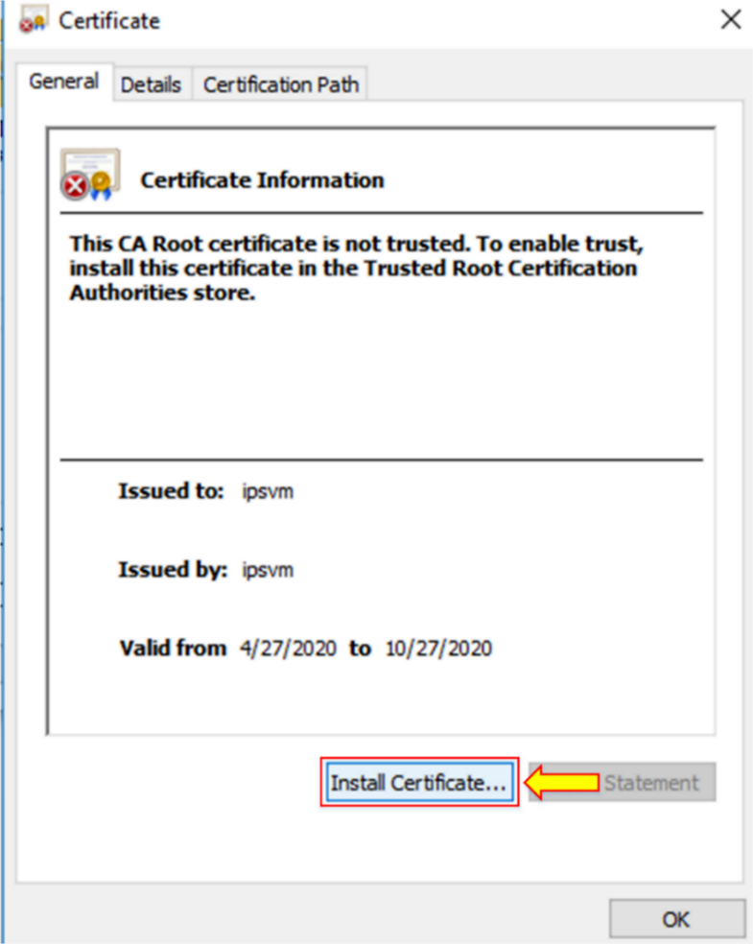

1. Click on “**OK”.**

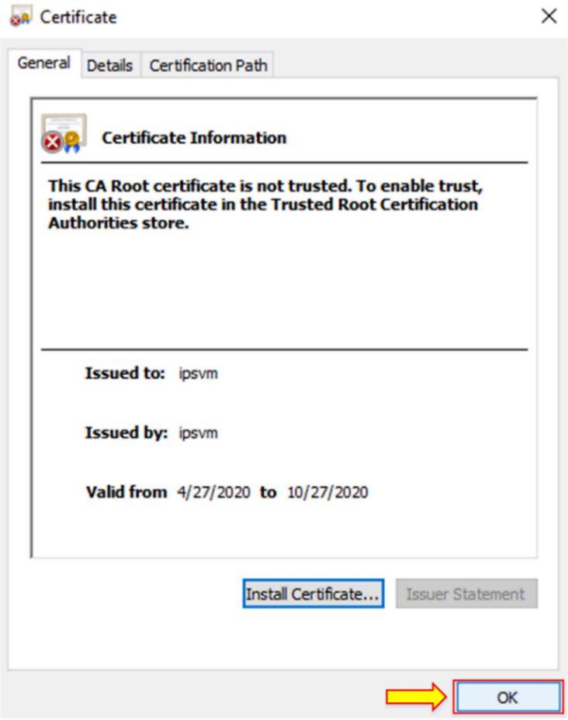

1. Click on “**Yes”.**

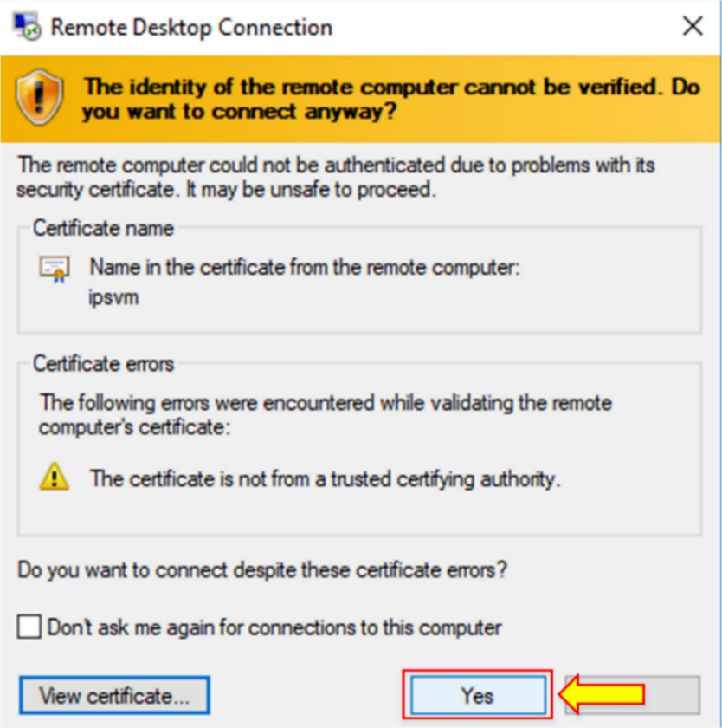

1. In the “**Remote Desktop Connection**” dialog box, click on **Connect.**

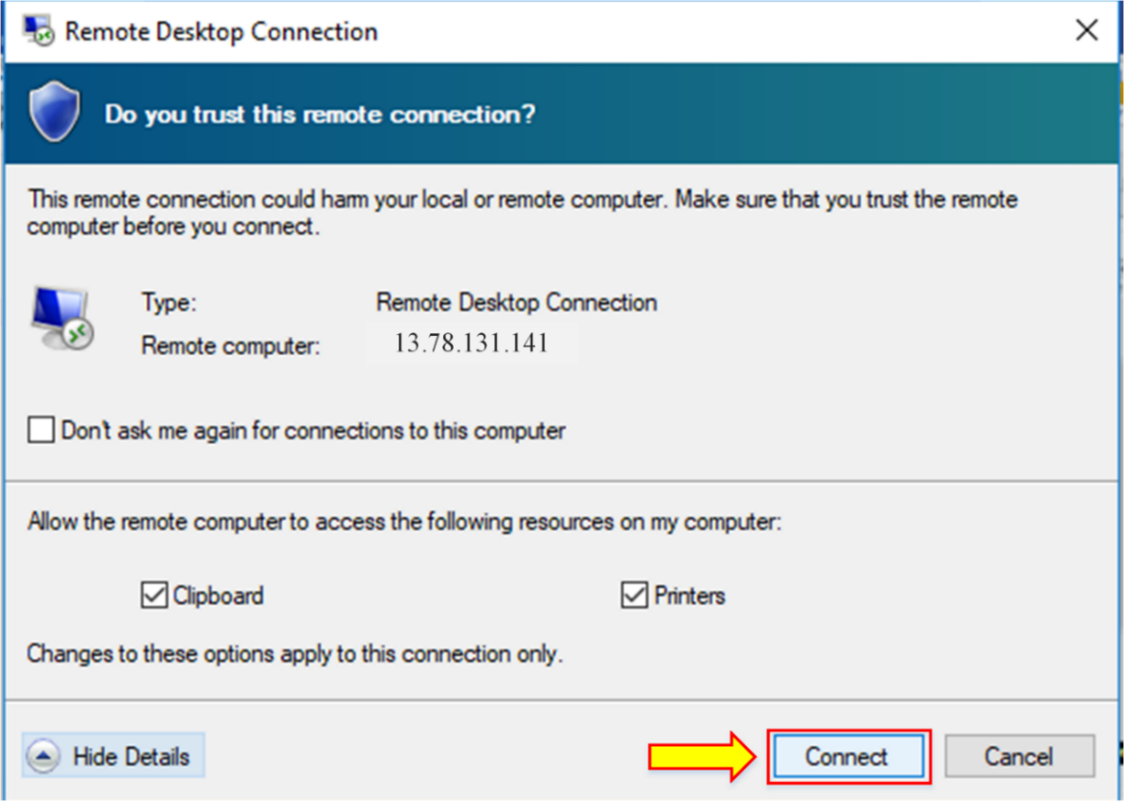

1. The “**Windows Security**” dialog box appears.
2. Enter the credentials and click on **“OK.”**

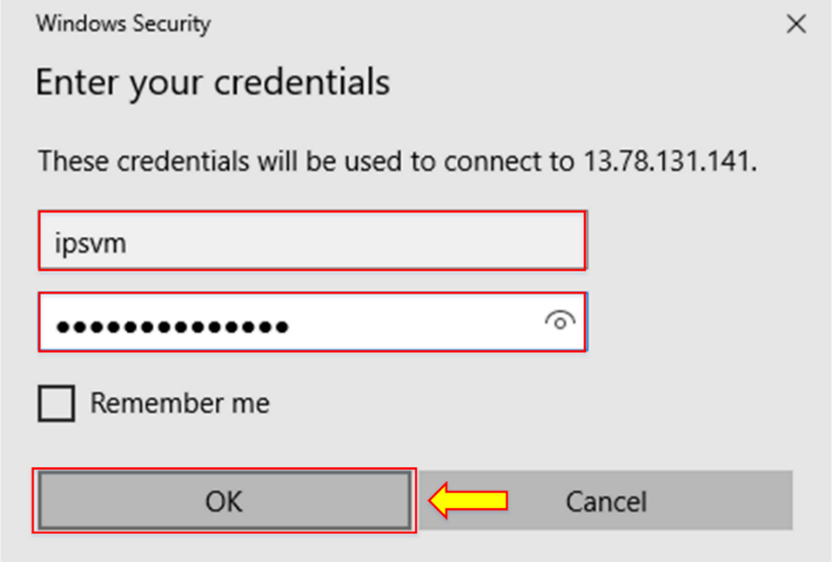

1. When you connect to Windows Server VM, the “**Server Manager**” will be launched.

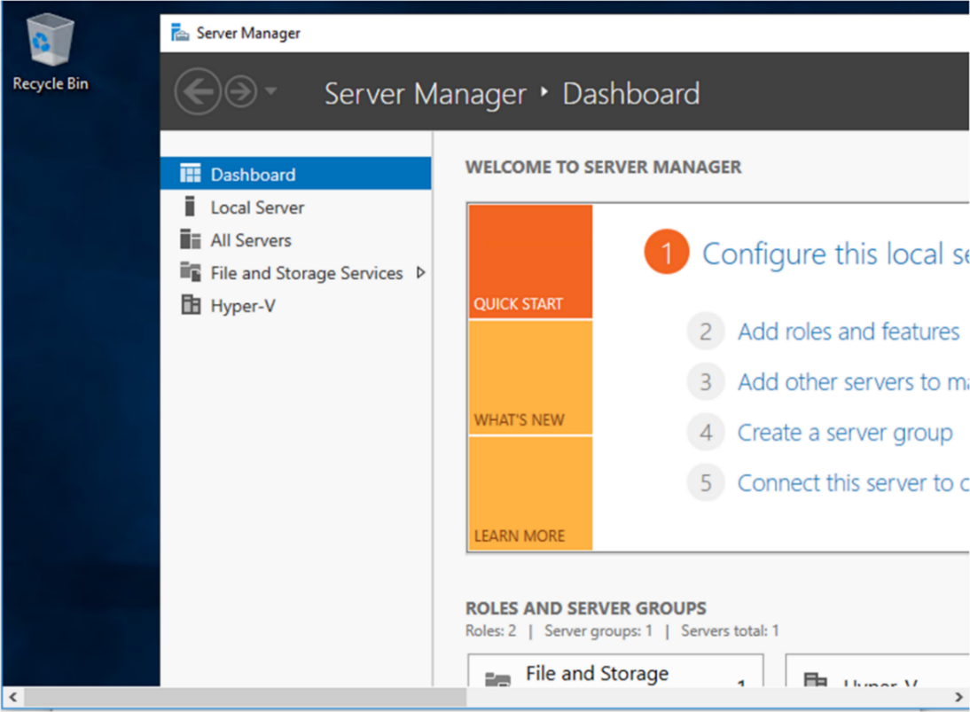

**Note:** When you connect to the Windows Server VM, you add the Web Server role. This connection will install Internet Information Service (IIS) to block all HTTP requests and enable the FTP server. The FTP server allows access to the folder on the data drive you have added to the VM.

1. Now, go to the start menu and search “**disk management.”**

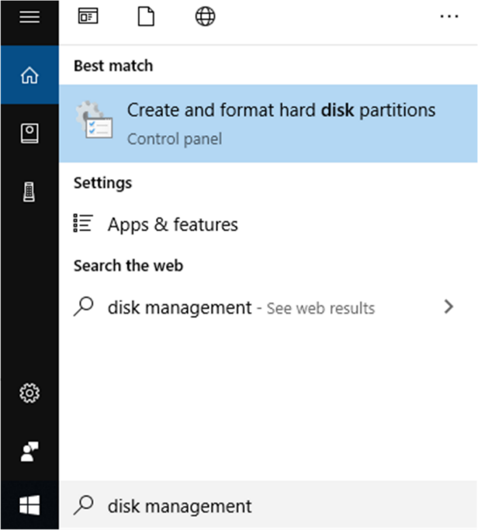

1. Select the number of disks.
2. Enable the style of the selected disk as “**Master Boot Record (MBR).”**
3. Click on “**OK”.**

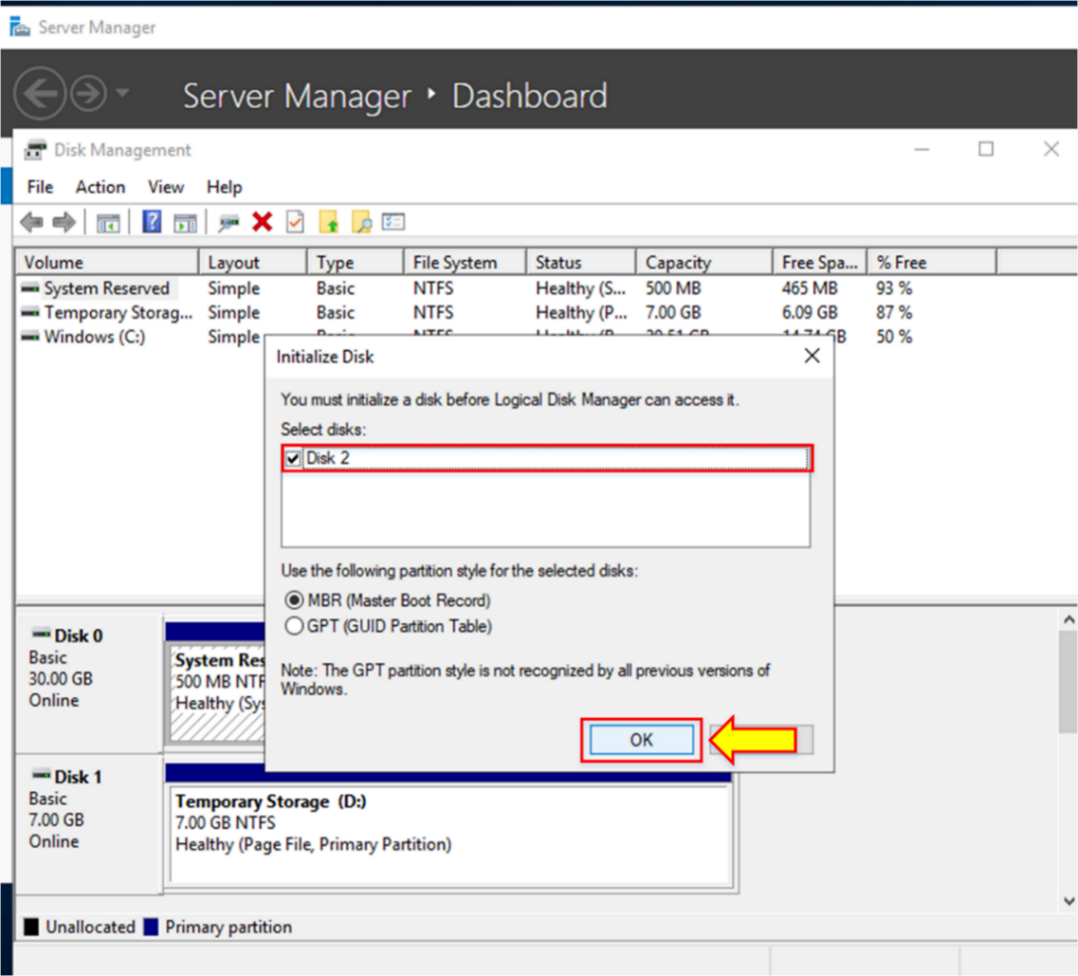

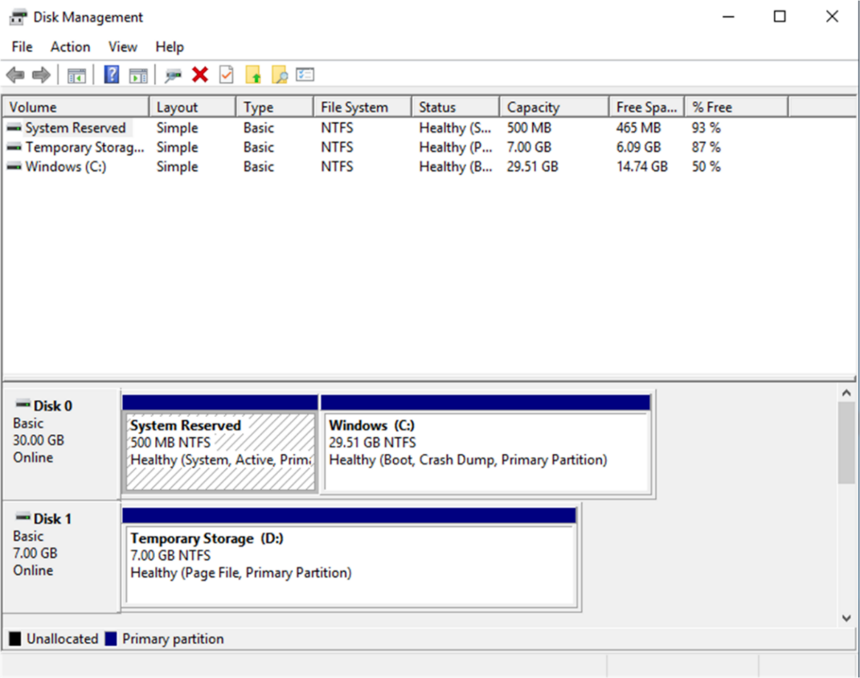

1. Now, go to the start menu again.
2. Search “**File Explorer.”**

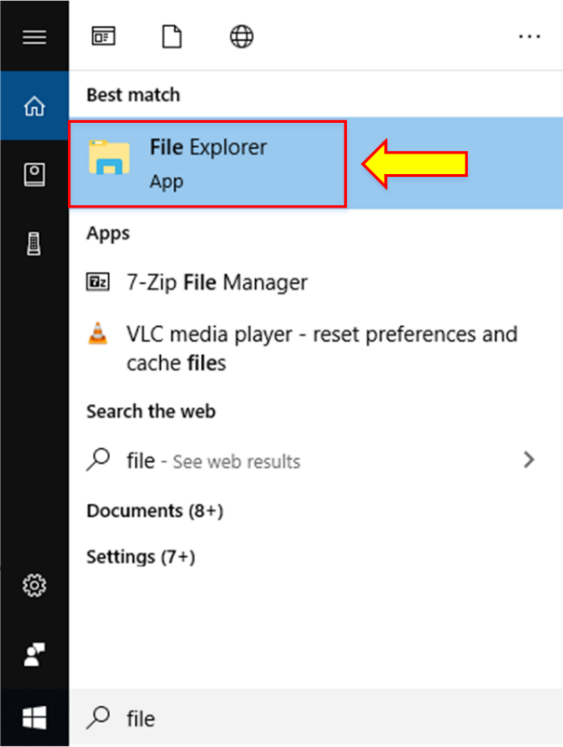

1. You will see your local data drive.

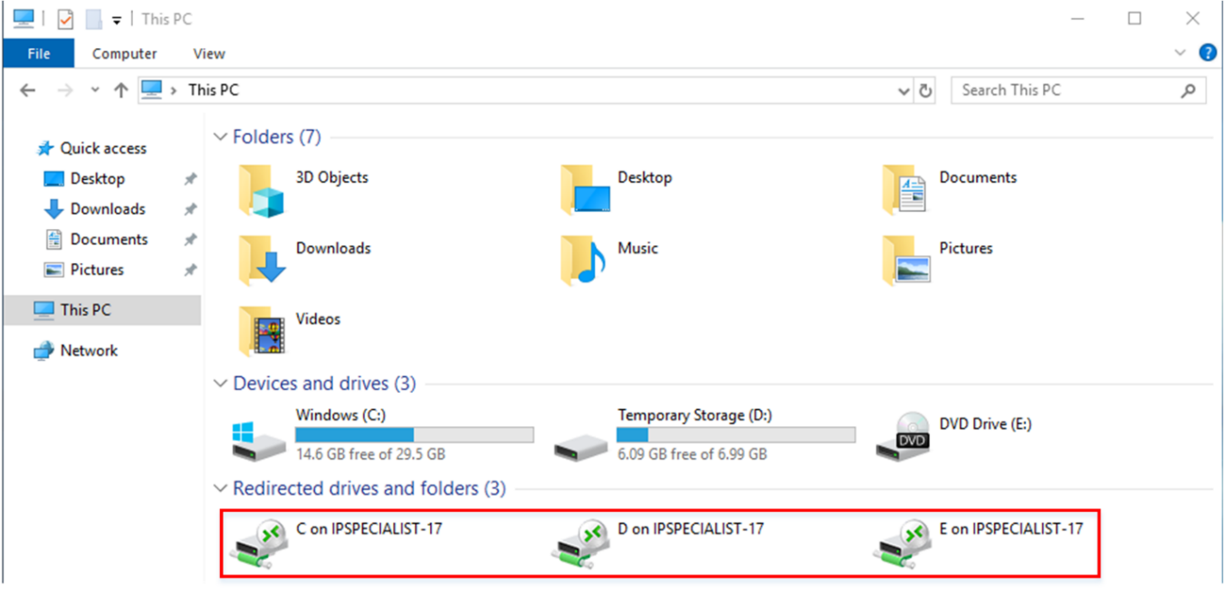

**Note:** Close the RDP client to sign out of the Virtual Machine (VM).

## Lab 2-03: Azure App Services

### Service Introduction

Azure App Service is a fully managed platform-as-a-service (PaaS) offering by Microsoft Azure that enables developers to build, deploy, and scale web apps, mobile app backends, and RESTful APIs effortlessly. It provides a robust and flexible environment that supports multiple programming languages, including .NET, Java, Node.js, Python, and more. With features like automatic scaling, continuous deployment, and integrated DevOps capabilities, Azure App Service streamlines the development process and allows developers to focus on coding instead of infrastructure management. Additionally, it offers built-in security features, including authentication and authorization, as well as seamless integration with Azure services like Azure SQL Database, Azure Storage, and Azure Functions, facilitating the creation of powerful and interconnected cloud applications. Overall, Azure App Service is a versatile and efficient solution for deploying and managing modern web and mobile applications in the Azure cloud.Top of Form

### Problem

An organization wants to deploy a web app by using an Azure service that provides a fully managed infrastructure environment for customers and developers to develop and manage applications without having to worry about managing the infrastructure. How can this be done?

### Solution

Azure App Service is a fully managed Platform as a Service (PaaS), which means servers, networks, storage, and other fundamental infrastructures are all managed and controlled by Azure. Web Apps allow to creation, deployment, and scale of Web Apps to enterprise grade in seconds.

|  |
| --- |
| **Step-by-Step Guide**  Below are some steps to creating a Web App using Azure App services.   1. Login to “**Azure portal**.” Select “**App Services”** from the dashboard.      1. Click the **“+ Add**” icon to create a Web App by providing the required details, such as the name of the App, resource group name, etc.      1. When you click on the **“+ Add button**,” you will see a screen where you can enter all the information needed to create a web app. All required fields are marked using an asterisk (*) symbol. 2. Select “**Subscription”** and create a resource group.      1. Provide a name to the resource group; we named it “**IPS_appservice.”**      1. Provide instance details such as name, publish, runtime stack, operating system, and region.      1. Create an App Service Plan. 2. When you click on “**App Service Plan**,” you will see a screen with the **“+ Create new**” button, allowing for creating a new App Service Plan.      1. Change the pricing tier. 2. When you click on this option, you will see another screen presenting available features for different tiers. This choice is essential feature-wise and will depend, in most cases, on the environmental characteristics you are planning, such as Dev/Test environments and Production applications.      1. The “Dev/Test” category shows F, D, and B tiers (free, shared, and basic). They are designed for simple dev/test scenarios and lightweight web applications that do not need features such as auto-scaling or backups. 2. Select the recommended pricing tiers that are F1.      1. The **“Production”** category offers powerful machines and advanced features useful in many realistic scenarios, such as APIs, e-commerce, and popular portals. 2. Select the recommended pricing tiers. 3. After selecting, click the “**Apply”** button.      1. Click the “**Review + create**” button after providing all the details required in the field.      1. After viewing that all the provided details are appropriate on the summary page, click the ‘**Create button,’** and you will see the notification about deployment initializing.      1. When the deployment is completed, click on “**Go to resource.”**      1. Go to the overview tab of the resource group; it will show the details of the app details. 2. Click on the URL, the link to the web app we created.      1. You will be presented with a page when you click on the URL, as shown below. |